
ROBUST GIFTING
2-in-1 Diary + Pen Catalogue
Premium Corporate Gifting Solutions
43 Premium Designs | Prices exclusive of 18% GST

Item No. 01  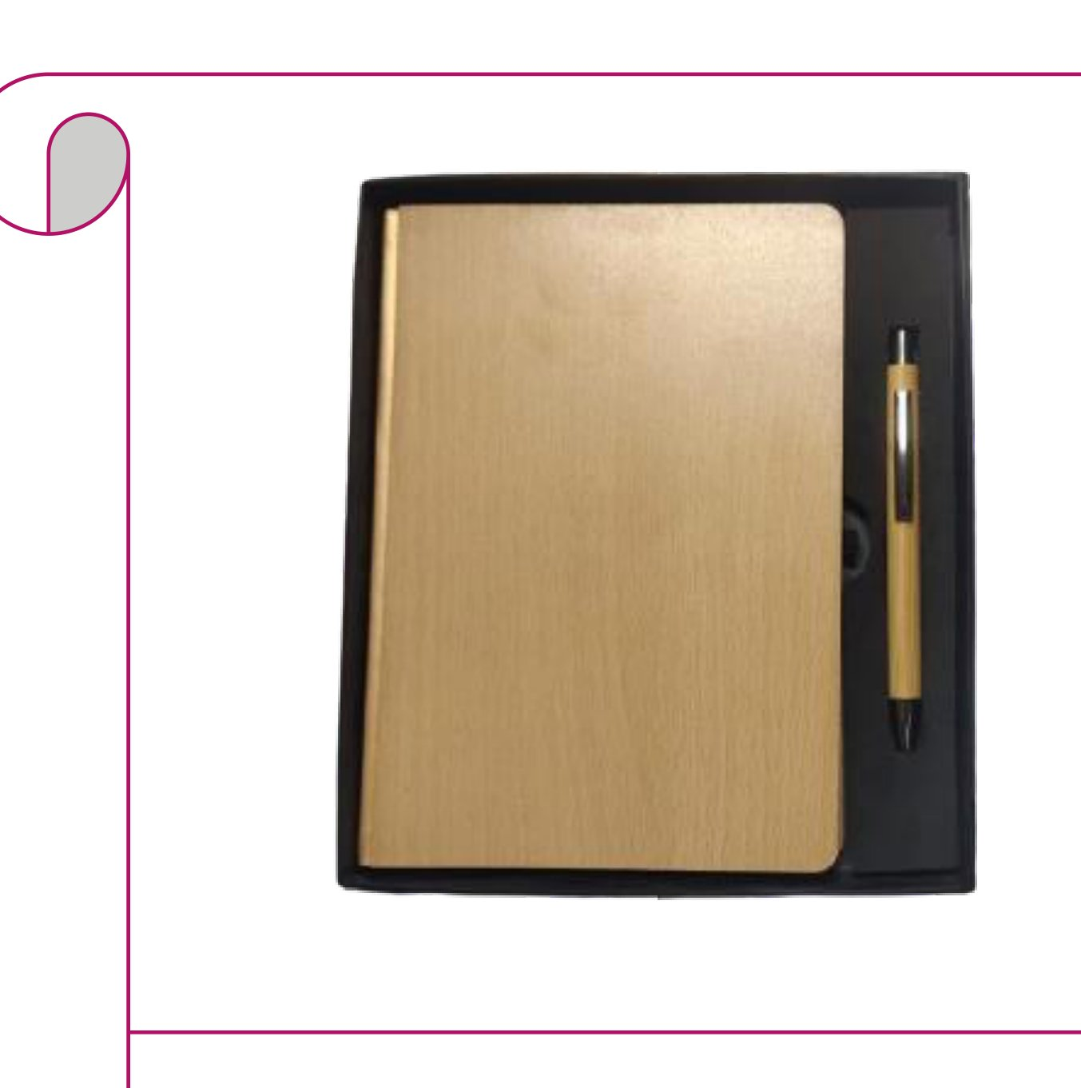  Bamboo Diary + Bamboo Pen  Natural bamboo-cover diary with matching bamboo barrel ballpoint pen  Rs. 207/- Base Rs. 175 + 18% GST |  | Item No. 02  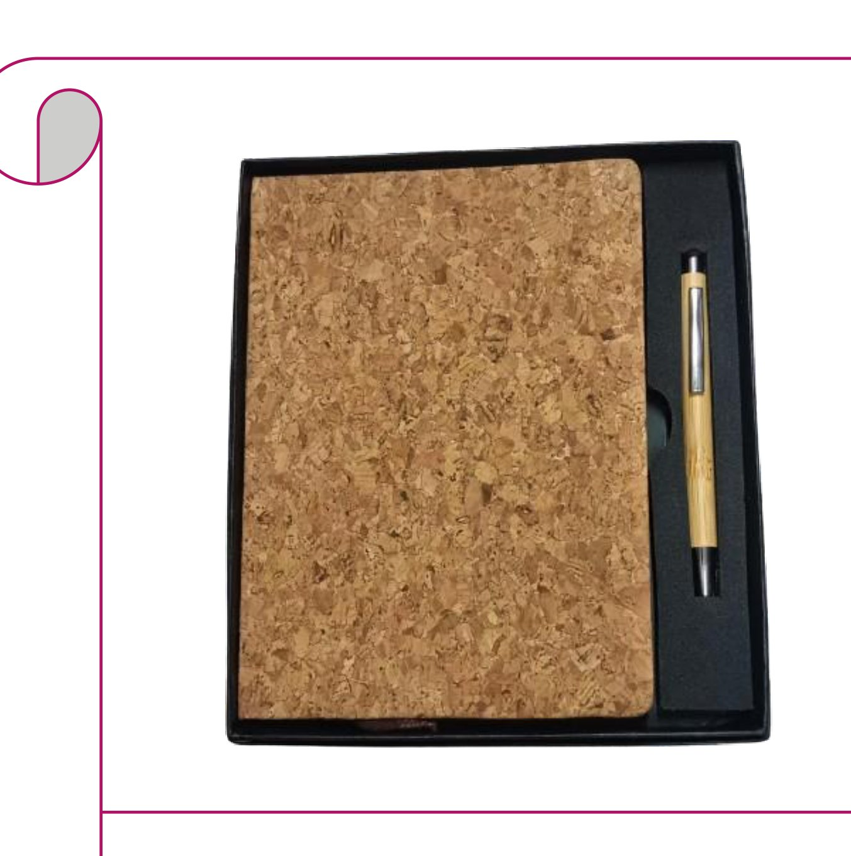  Cork Diary + Bamboo Pen  Full cork-cover diary paired with a bamboo barrel ballpoint pen  Rs. 207/- Base Rs. 175 + 18% GST
Item No. 03  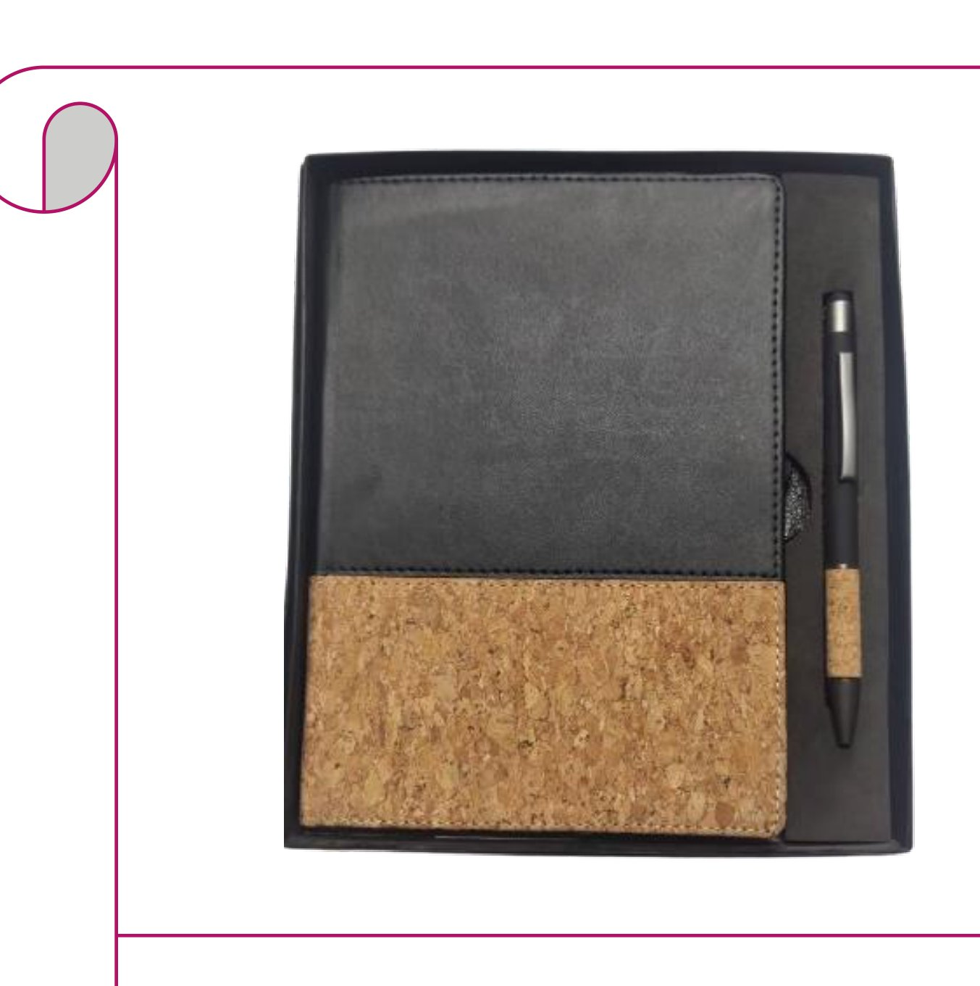  Cork & Black Diary + Cork Pen  Black leatherette & cork diary with a cork-grip ballpoint pen  Rs. 207/- Base Rs. 175 + 18% GST |  | Item No. 04  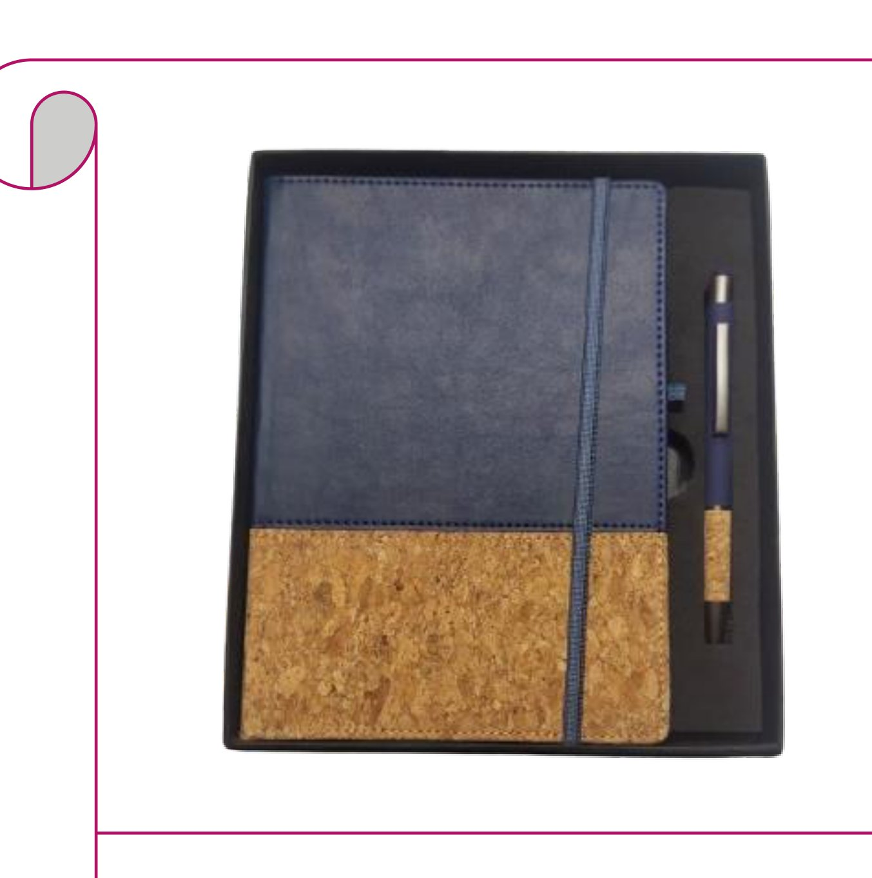  Blue Cork Diary + Cork Pen  Blue leatherette & cork diary with a matching cork-grip pen  Rs. 207/- Base Rs. 175 + 18% GST
Item No. 05  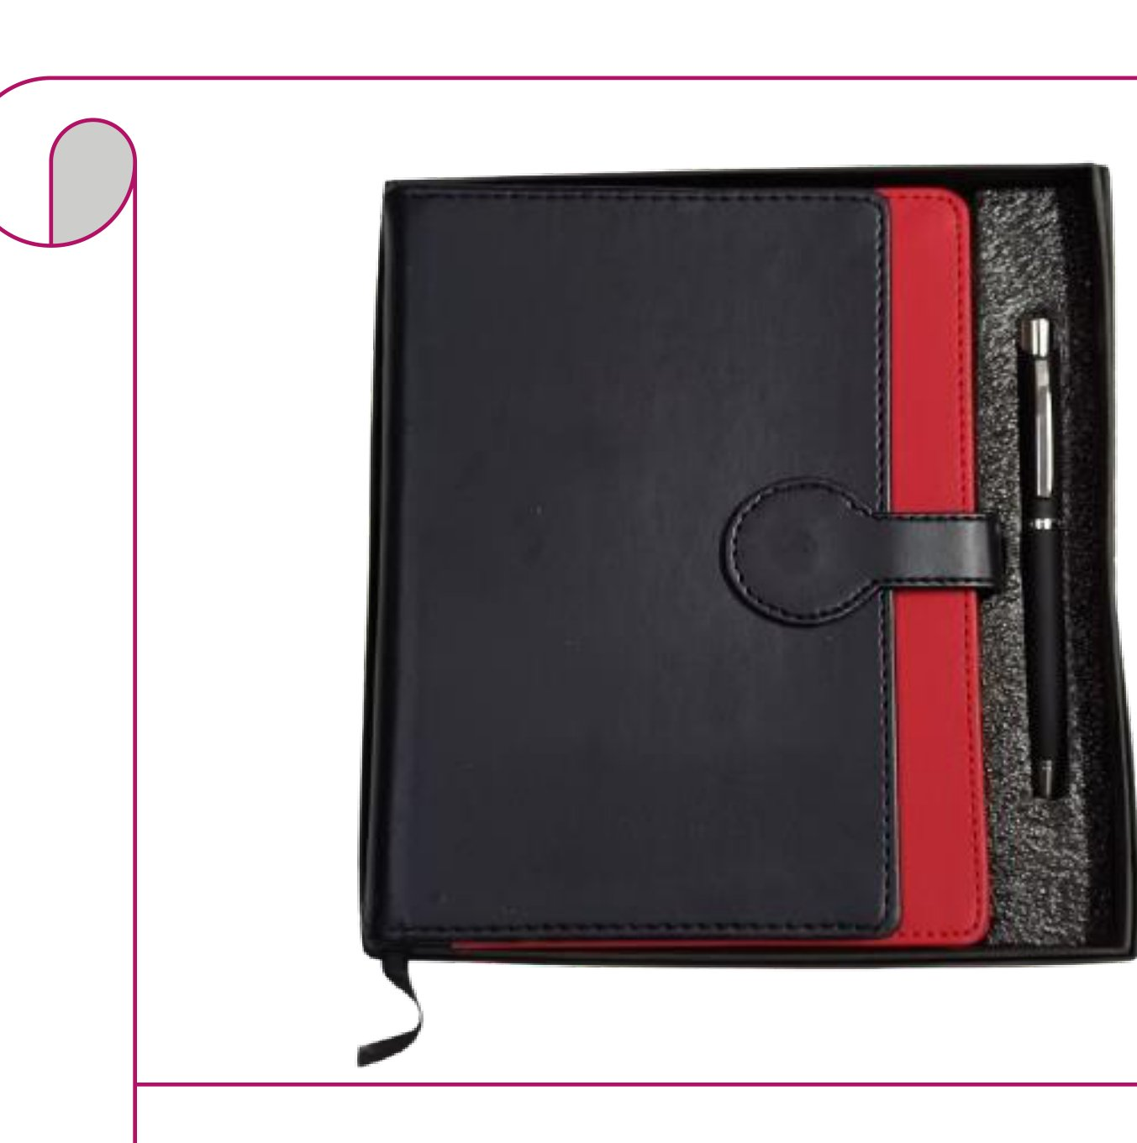  Black & Red Diary + Chrome Pen  Black & red faux leather clasp diary with a chrome roller pen  Rs. 295/- Base Rs. 250 + 18% GST |  | Item No. 06  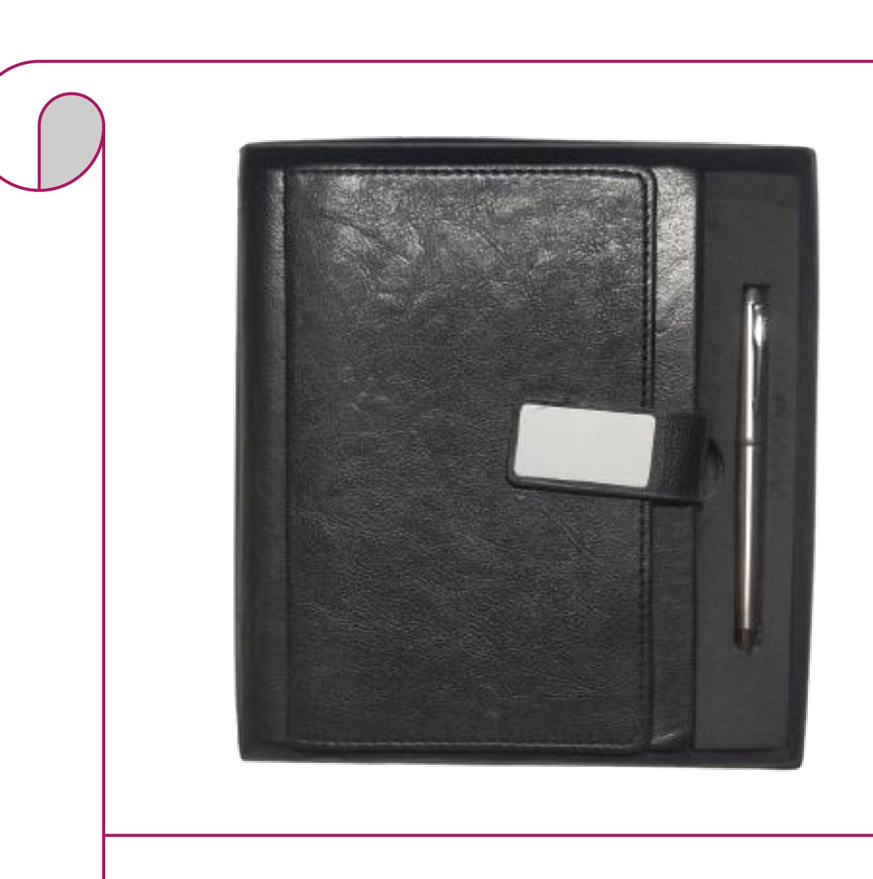  Black Textured Diary + Silver Pen  Black croc-texture leather diary with name-badge clasp and silver pen  Rs. 295/- Base Rs. 250 + 18% GST
Item No. 07  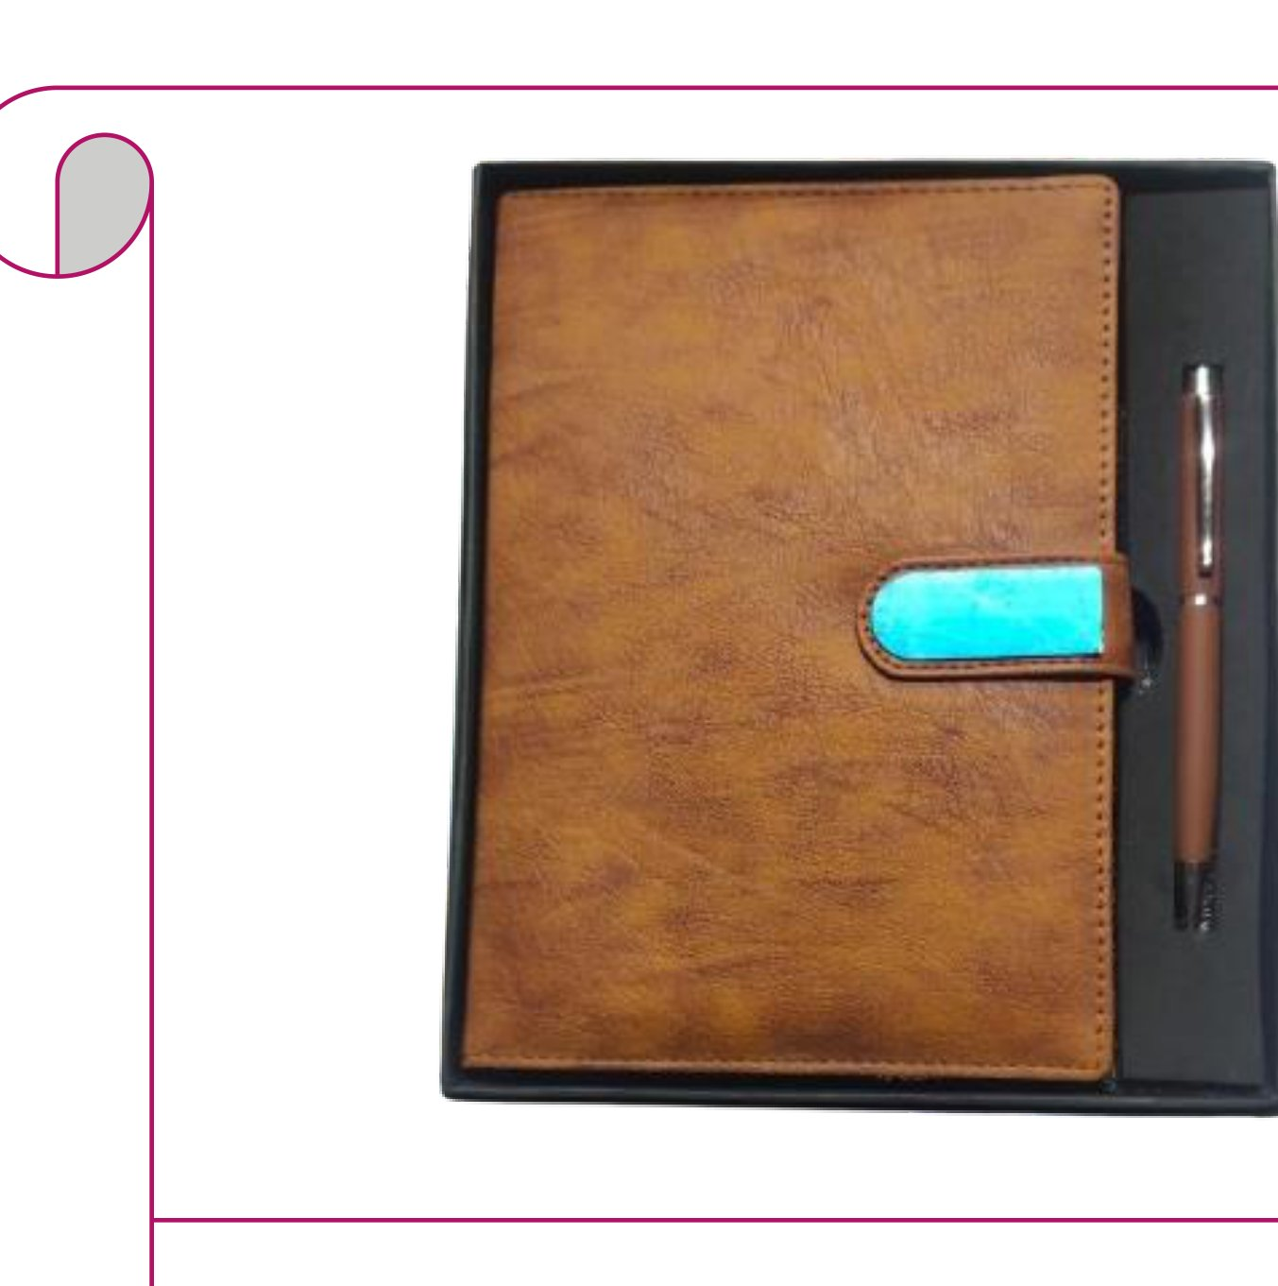  Tan Leather Diary + Wooden Pen  Tan distressed leather clasp diary paired with a wooden-body pen  Rs. 295/- Base Rs. 250 + 18% GST |  | Item No. 08  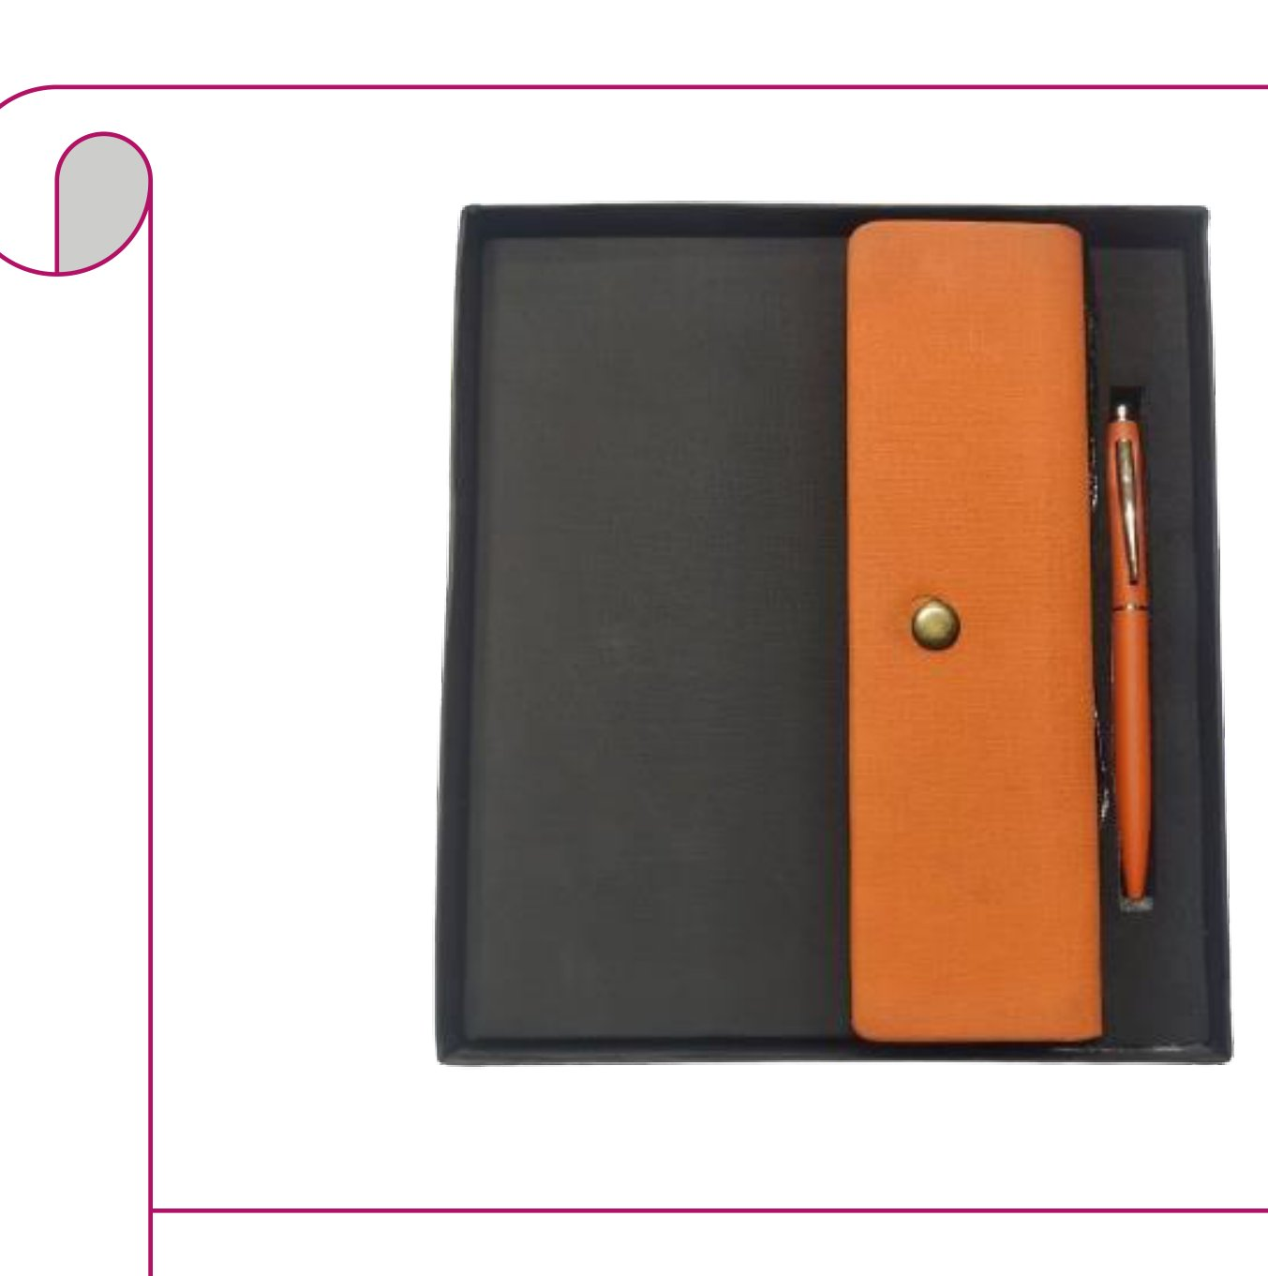  Orange Leatherette Diary + Pen  Orange leatherette snap-button diary with a matching orange pen  Rs. 295/- Base Rs. 250 + 18% GST
Item No. 09  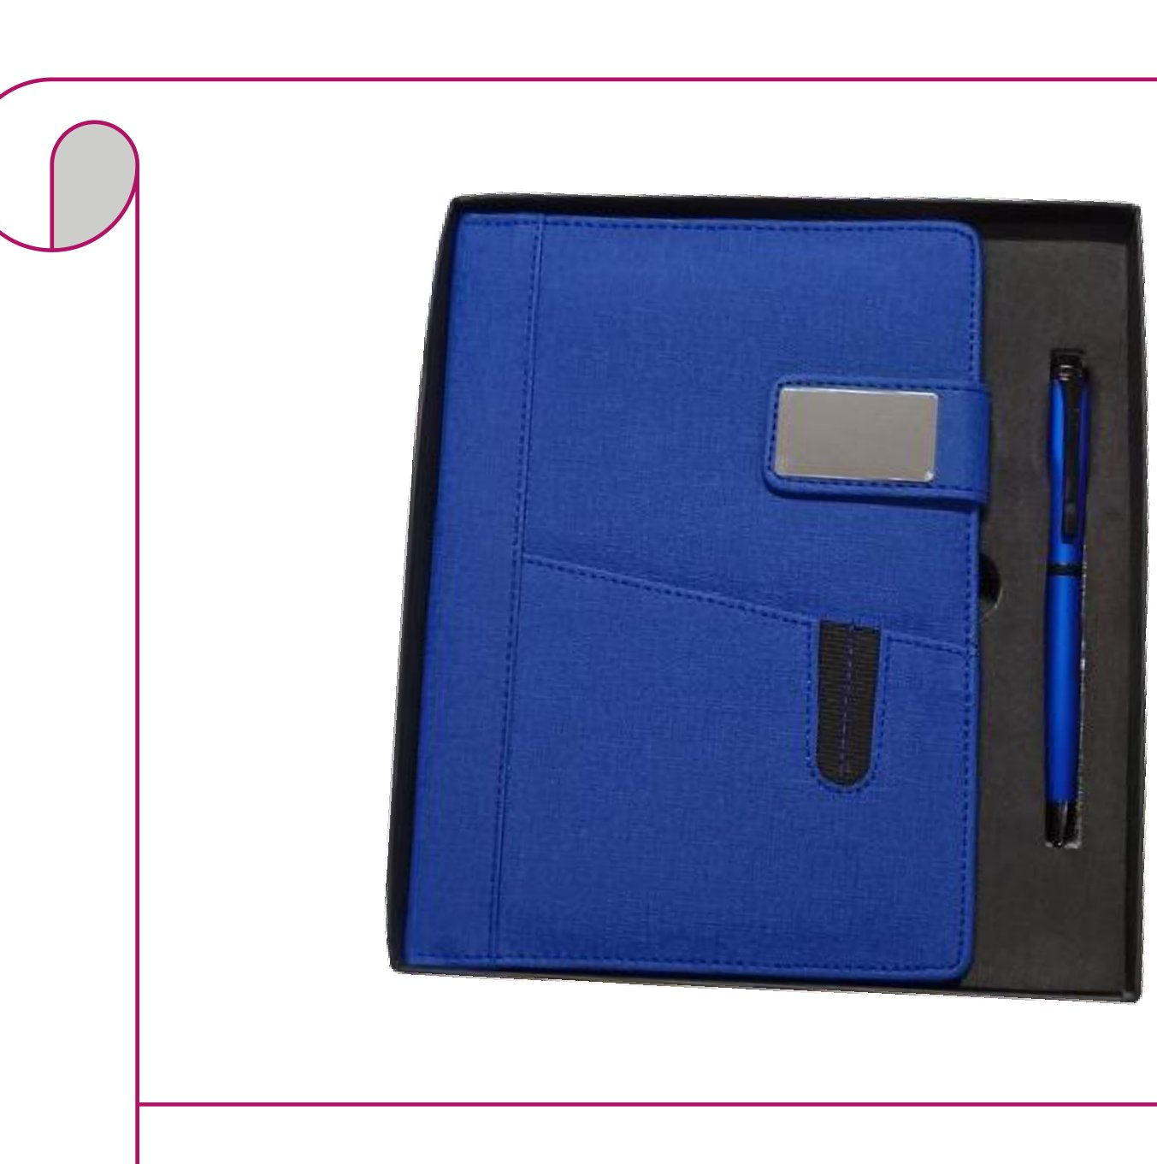  Royal Blue Fabric Diary + Pen  Royal blue fabric diary with metal badge clasp and matching blue pen  Rs. 283/- Base Rs. 240 + 18% GST |  | Item No. 10  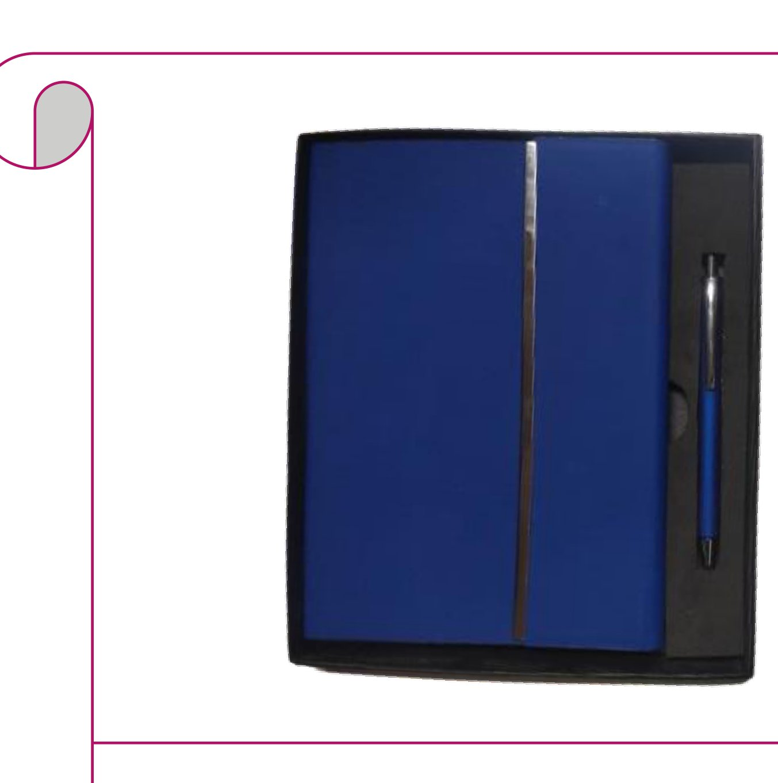  Cobalt Blue Hardcover Diary + Pen  Cobalt blue hardcover diary with chrome spine bar and chrome pen  Rs. 313/- Base Rs. 265 + 18% GST
Item No. 11  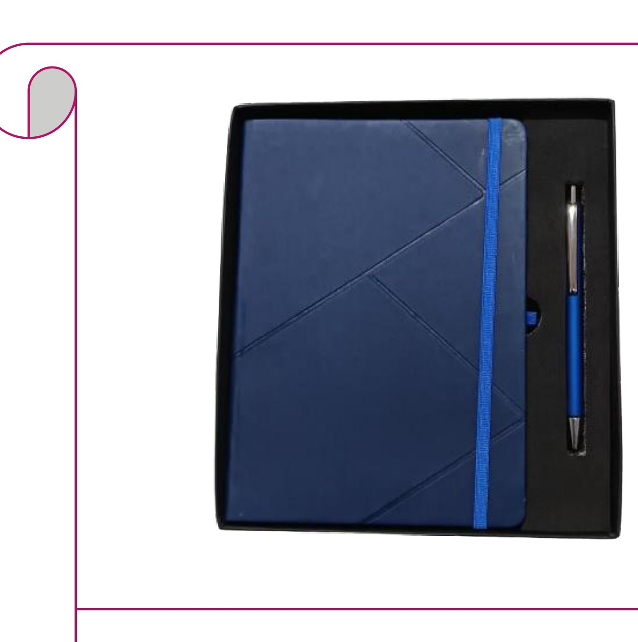  Navy Geometric Diary + Blue Pen  Navy leatherette diary with geometric embossing, elastic band & blue pen  Rs. 207/- Base Rs. 175 + 18% GST |  | Item No. 12  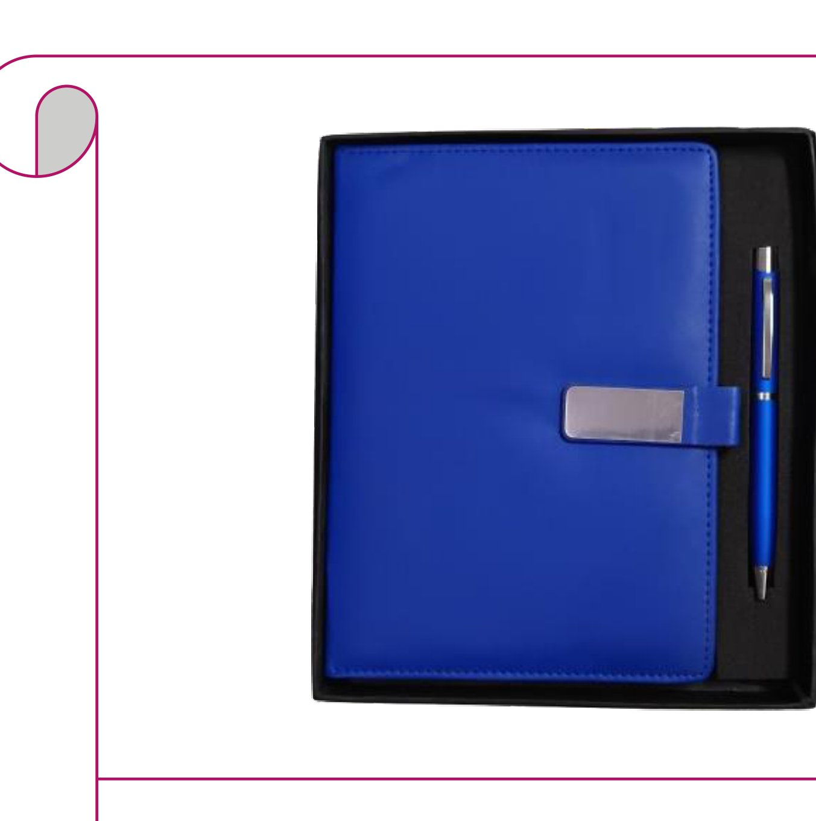  Cobalt Blue Clasp Diary + Pen  Cobalt blue diary with silver clasp and matching cobalt blue pen  Rs. 248/- Base Rs. 210 + 18% GST
Item No. 13  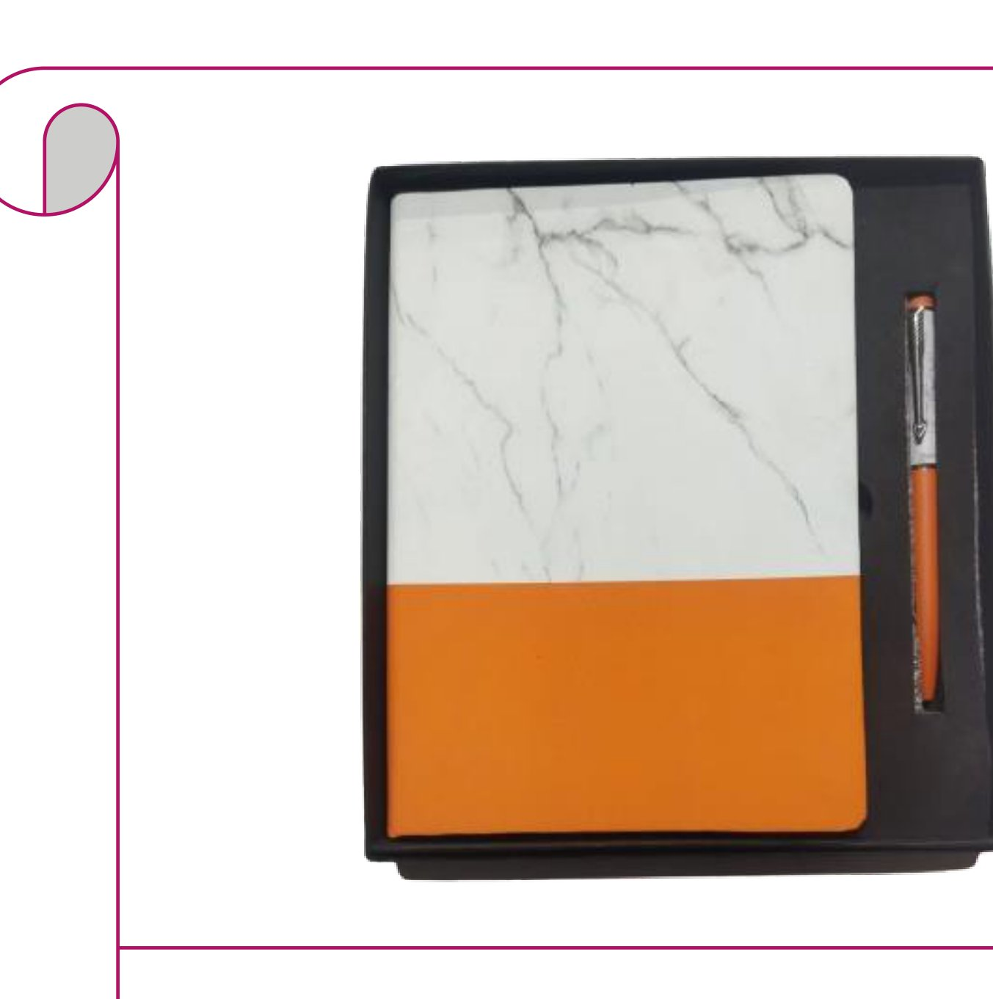  Marble & Orange Diary + Pen  White marble & orange bi-tone diary with an orange metallic pen  Rs. 207/- Base Rs. 175 + 18% GST |  | Item No. 14  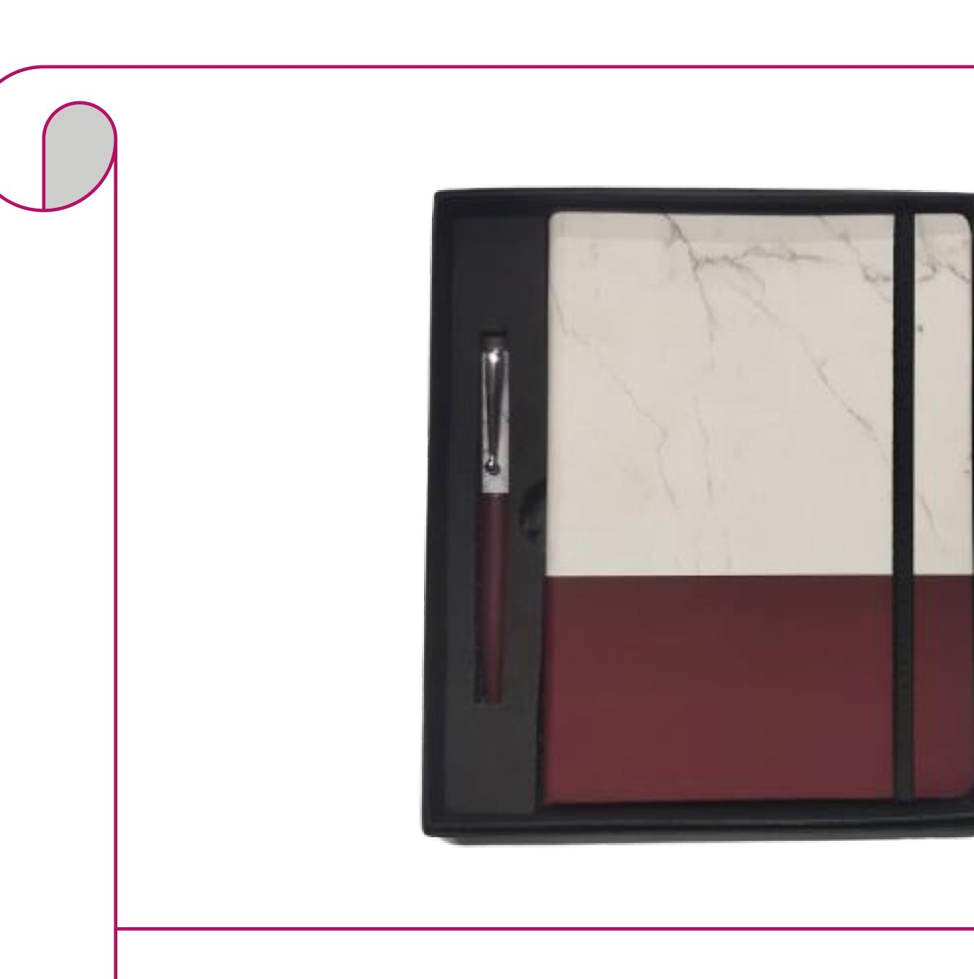  Marble & Burgundy Diary + Pen  White marble & burgundy bi-tone diary with a burgundy pen  Rs. 207/- Base Rs. 175 + 18% GST
Item No. 15  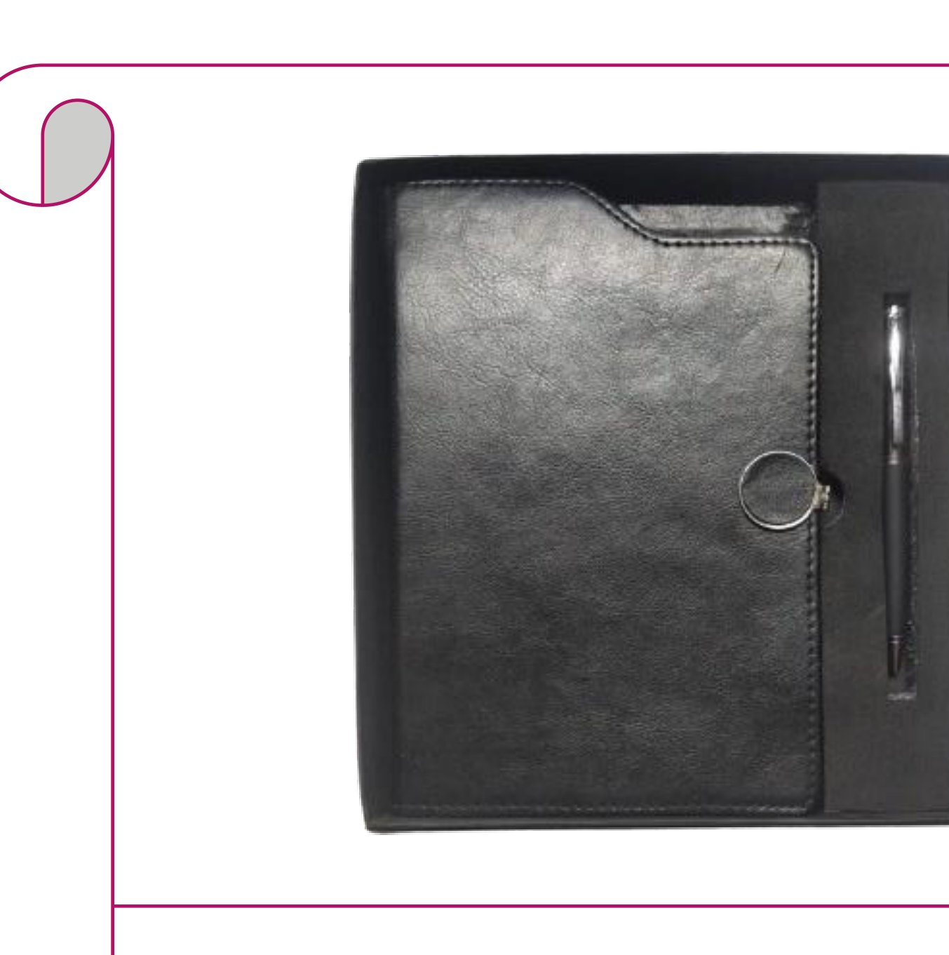  Black Ring-Clasp Diary + Pen  Black leather diary with round ring clasp and sleek black pen  Rs. 313/- Base Rs. 265 + 18% GST |  | Item No. 16  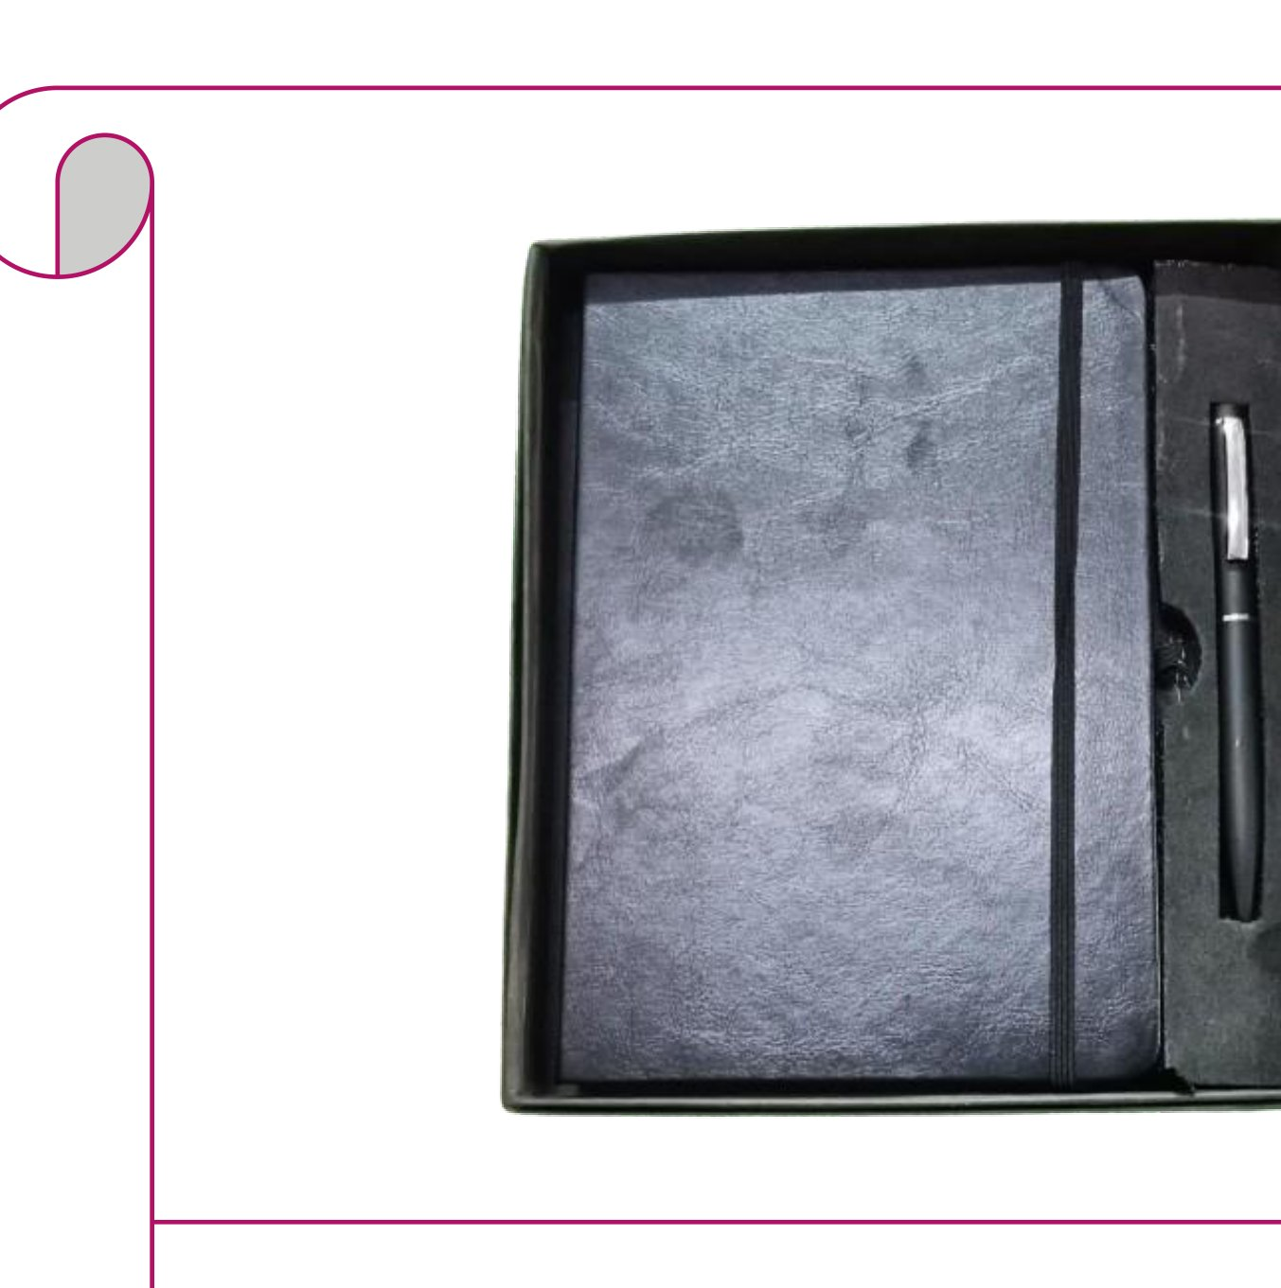  Charcoal Diary + Black Pen  Charcoal distressed leatherette diary with elastic band and black pen  Rs. 177/- Base Rs. 150 + 18% GST
Item No. 17  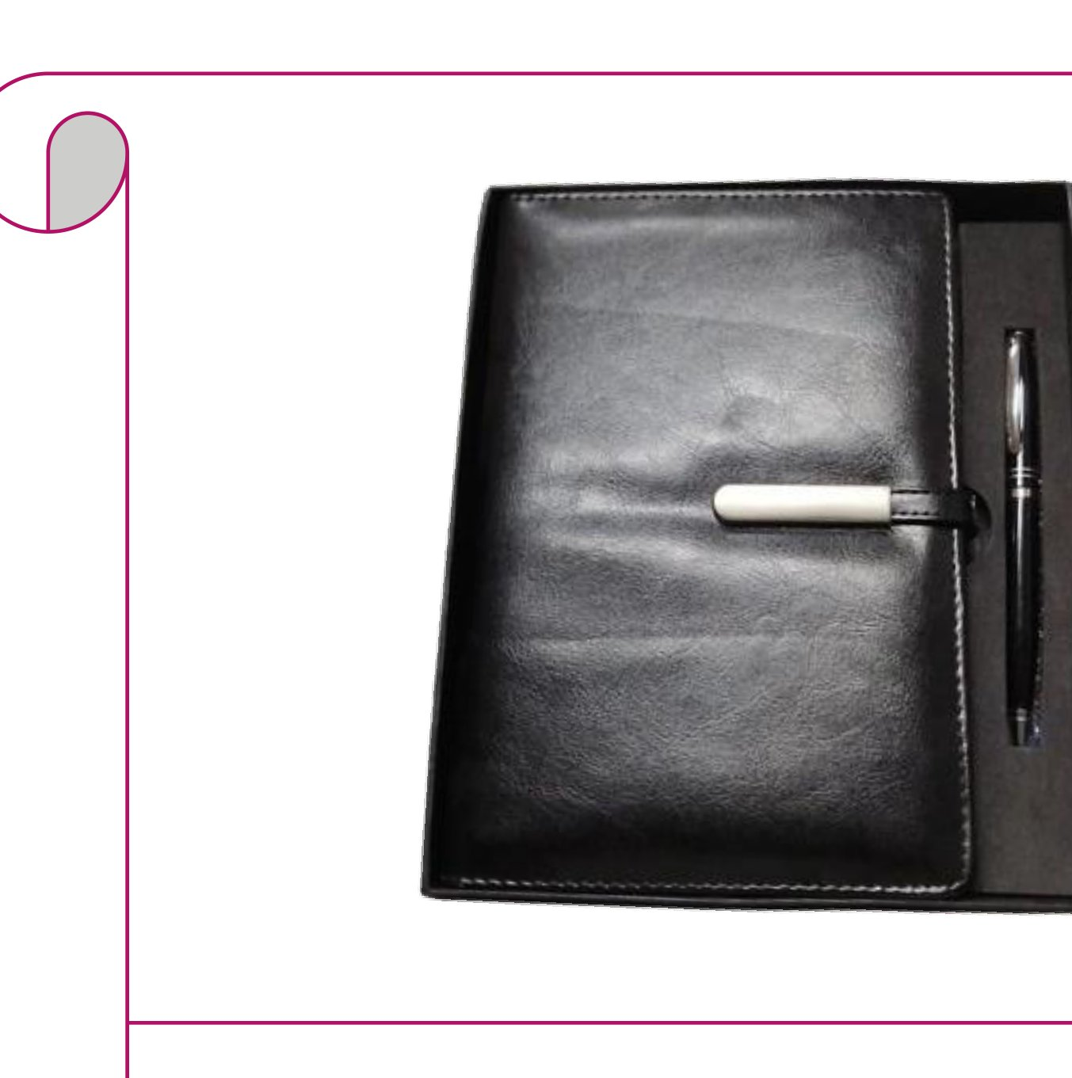  Black Leather Diary + Dark Pen  Black leather diary with white metal tab clasp and matte black pen  Rs. 277/- Base Rs. 235 + 18% GST |  | Item No. 18  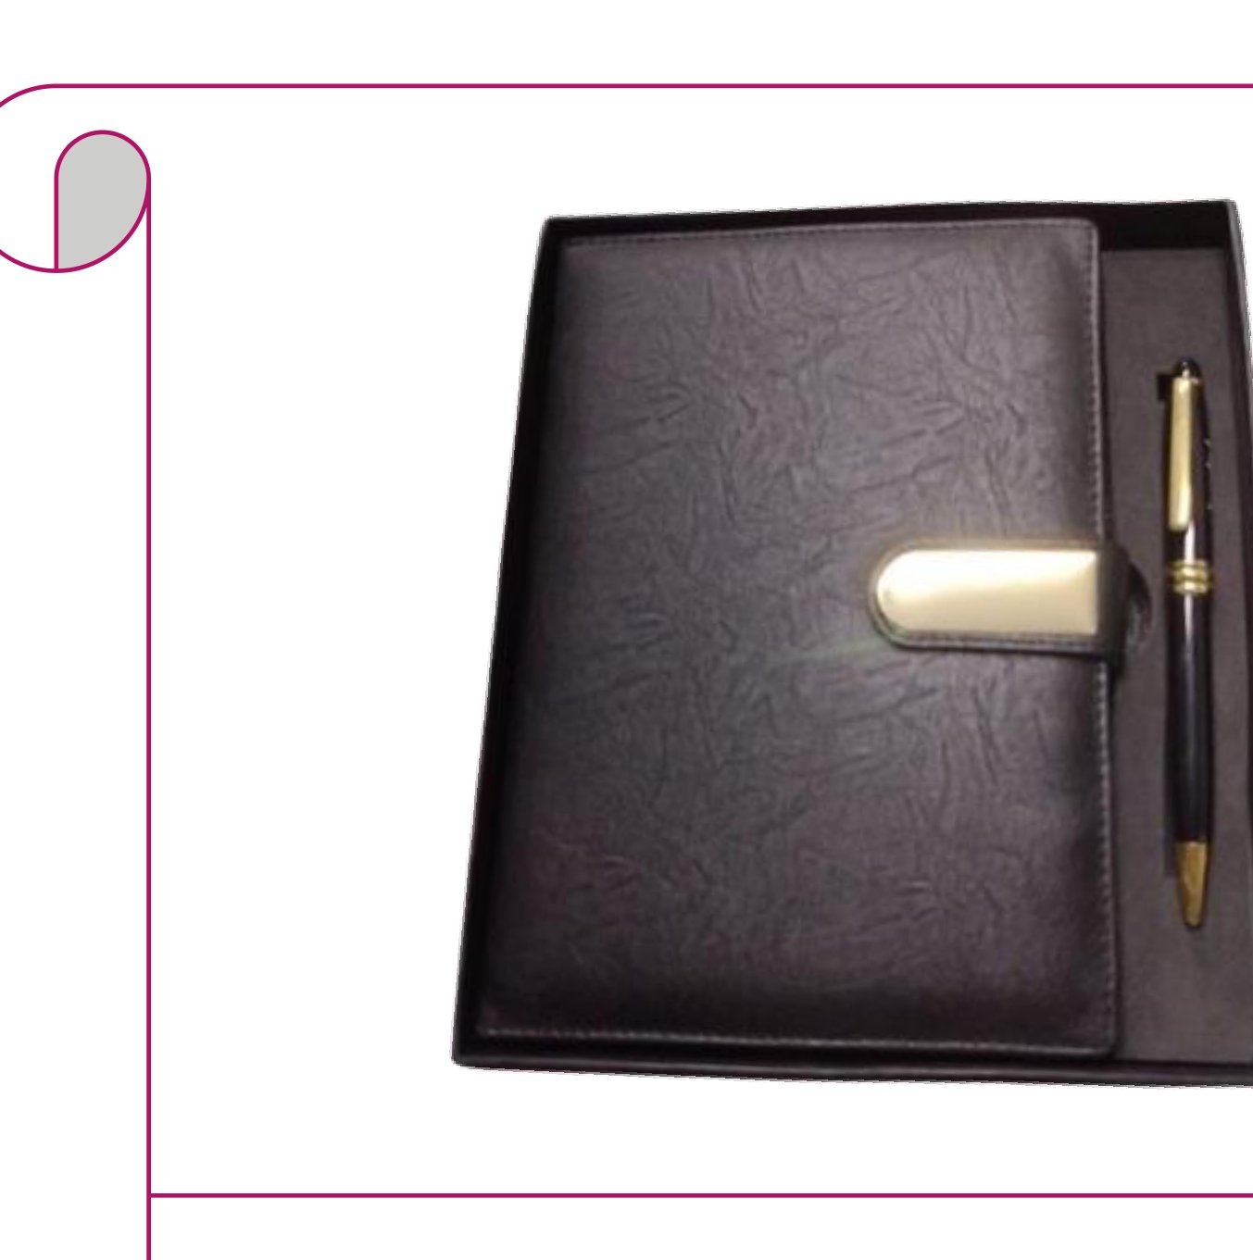  Brown Embossed Diary + Gold Pen  Dark brown embossed diary with gold clasp and black & gold pen  Rs. 295/- Base Rs. 250 + 18% GST
Item No. 19  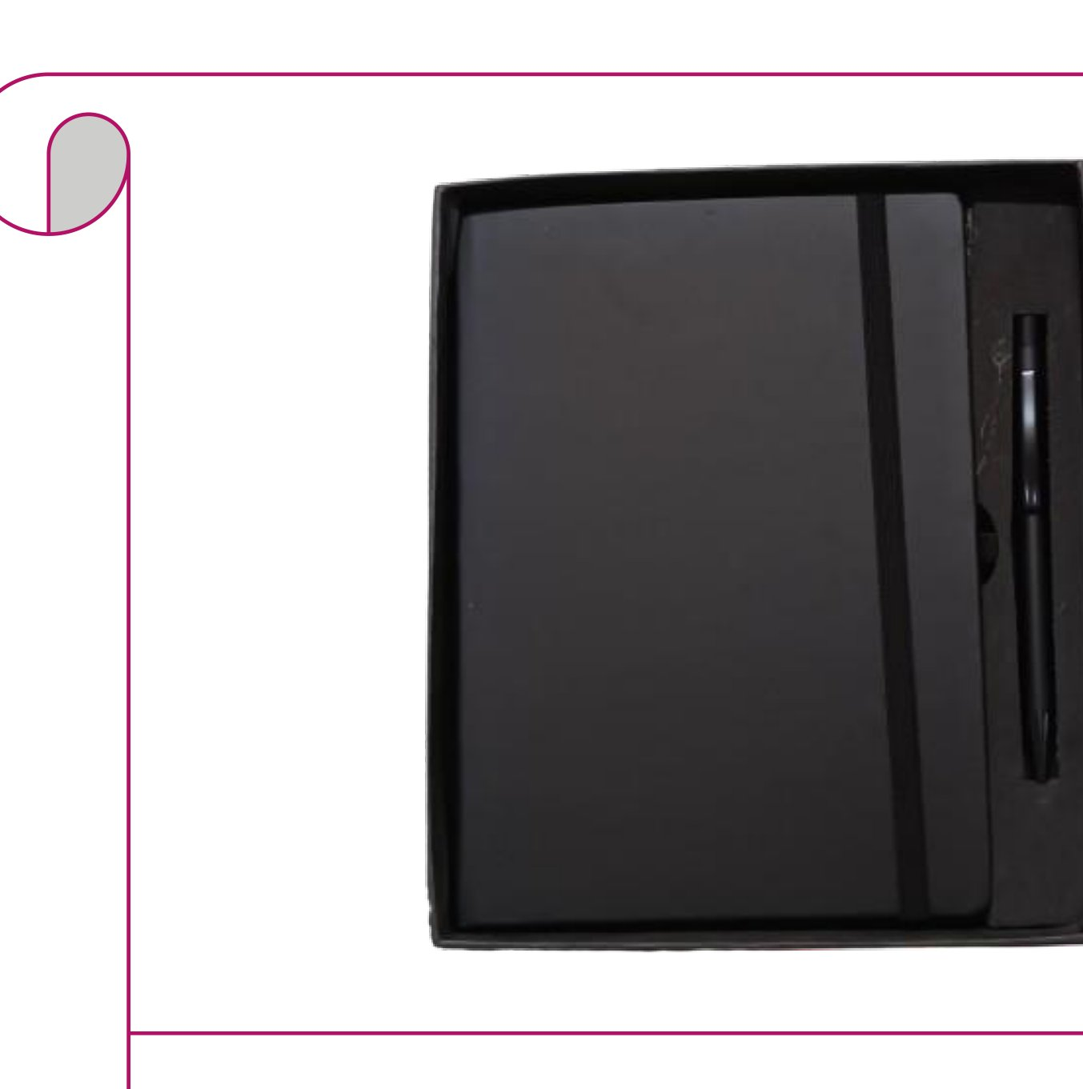  All-Black Diary + Black Pen  All-black leatherette diary with elastic band and black pen  Rs. 177/- Base Rs. 150 + 18% GST |  | Item No. 20  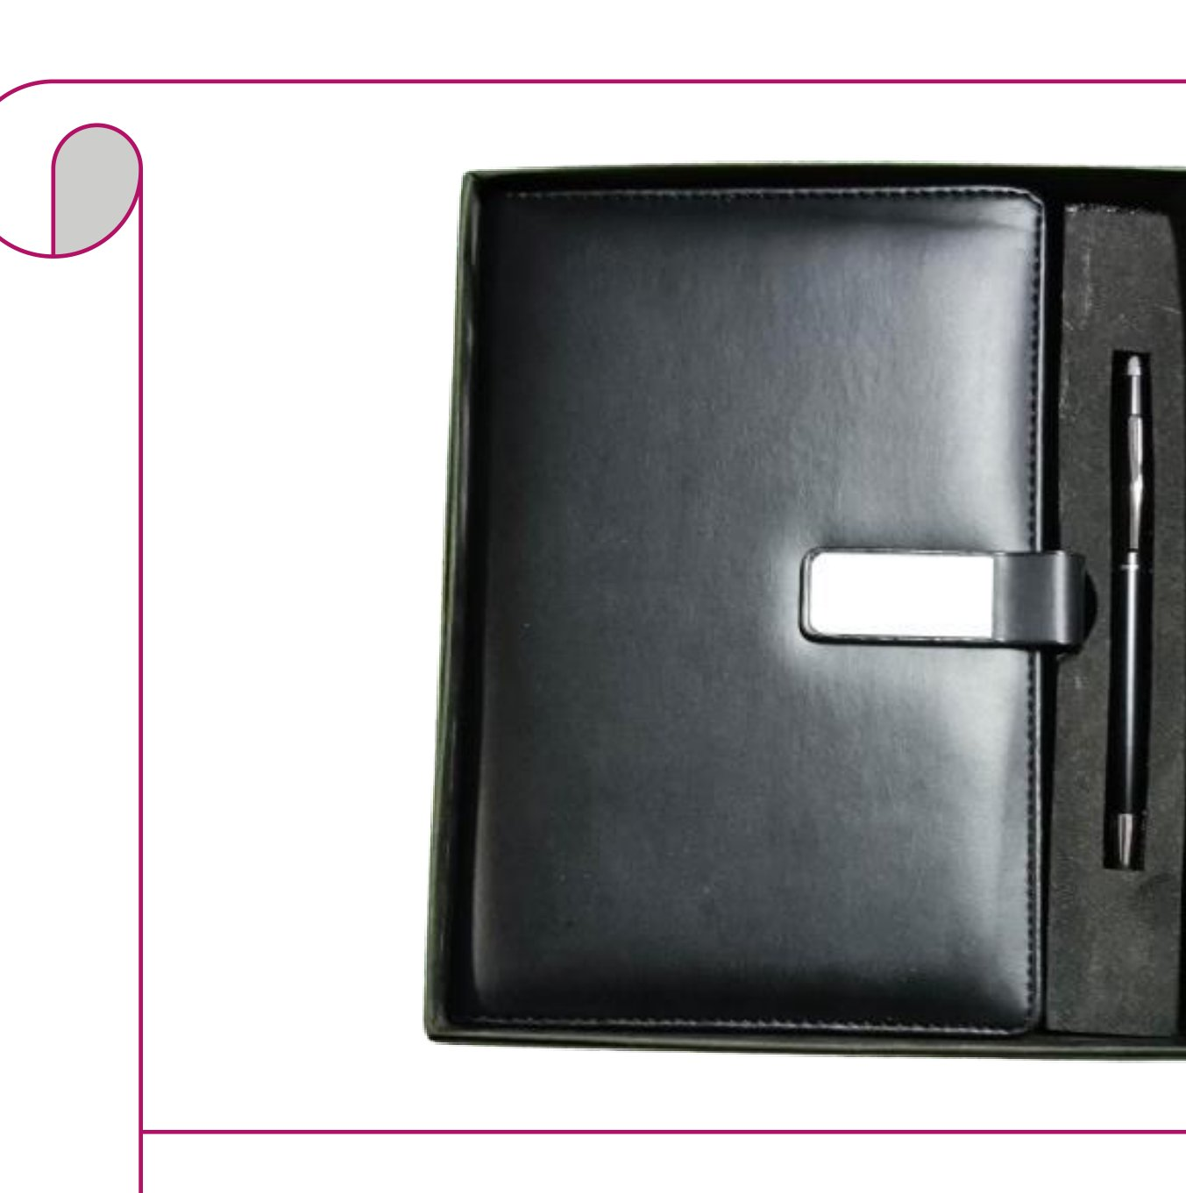  Black Glossy Diary + Dark Pen  Black glossy leather diary with metal tab clasp and matte dark pen  Rs. 248/- Base Rs. 210 + 18% GST
Item No. 21  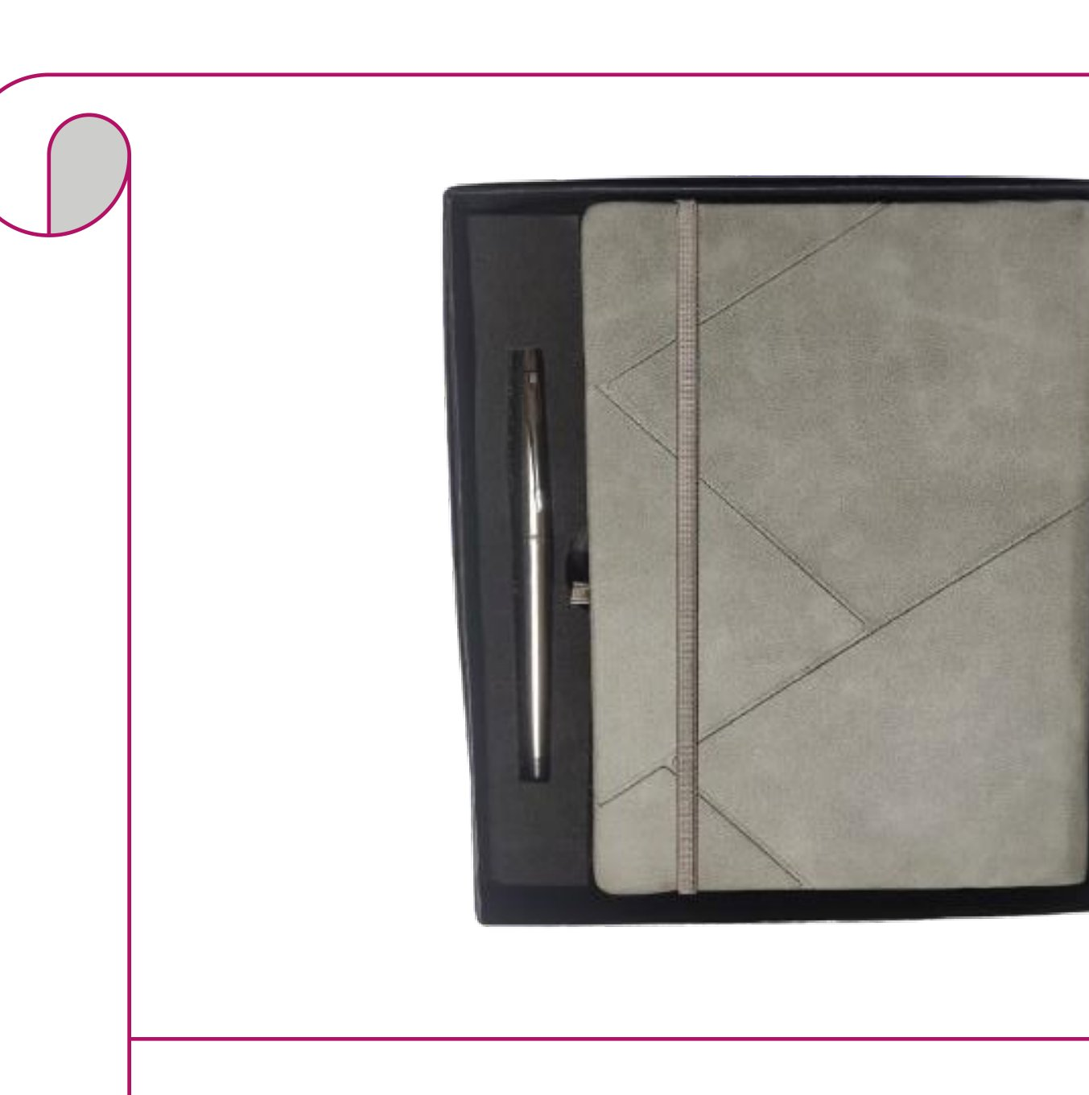  Grey Suede Geometric Diary + Pen  Grey suede diary with geometric cut-lines and silver chrome pen  Rs. 207/- Base Rs. 175 + 18% GST |  | Item No. 22  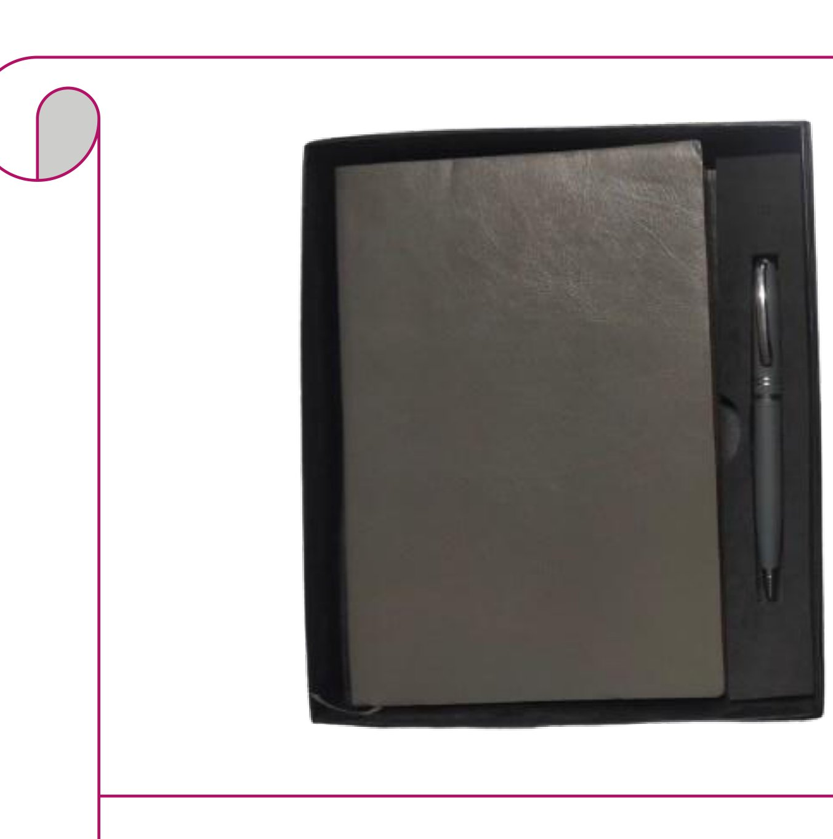  Soft Silver-Grey Diary + Pen  Soft silver-grey leatherette diary with a matching grey pen  Rs. 159/- Base Rs. 135 + 18% GST
Item No. 23  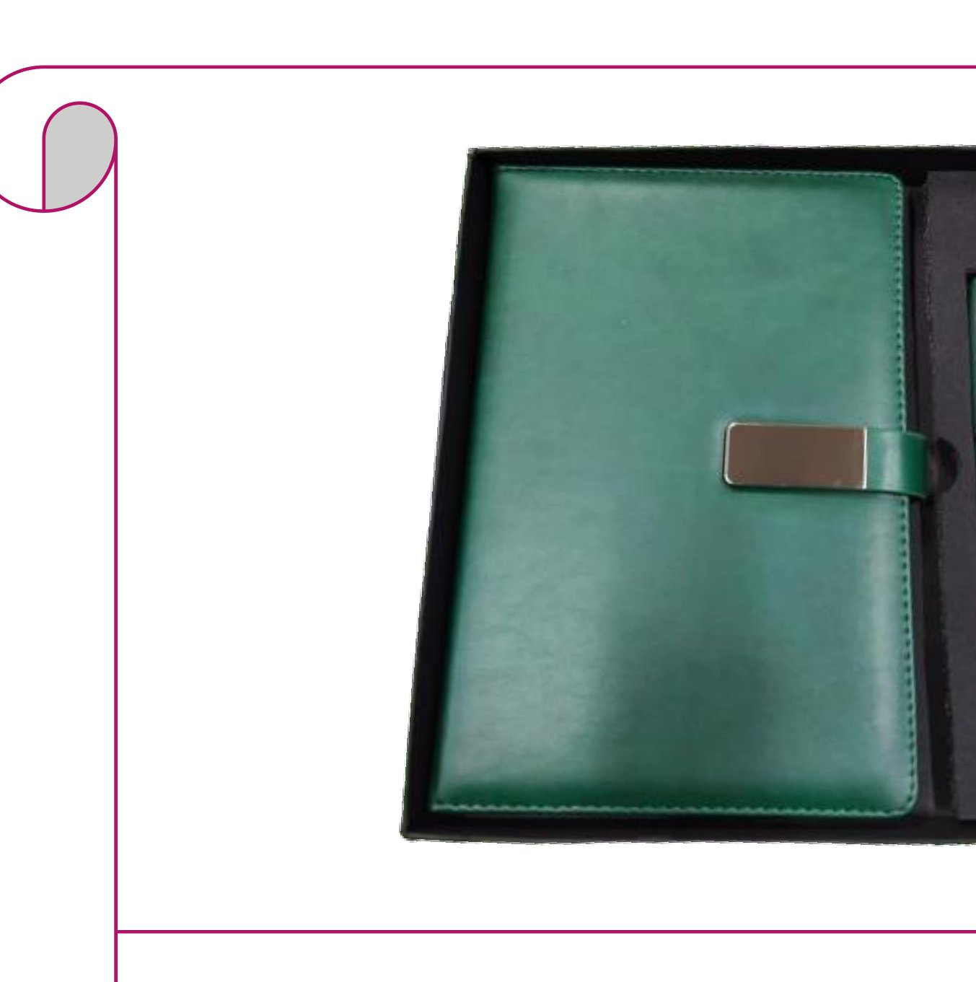  Emerald Green Diary + Green Pen  Emerald green diary with silver clasp and matching green ballpoint pen  Rs. 248/- Base Rs. 210 + 18% GST |  | Item No. 24  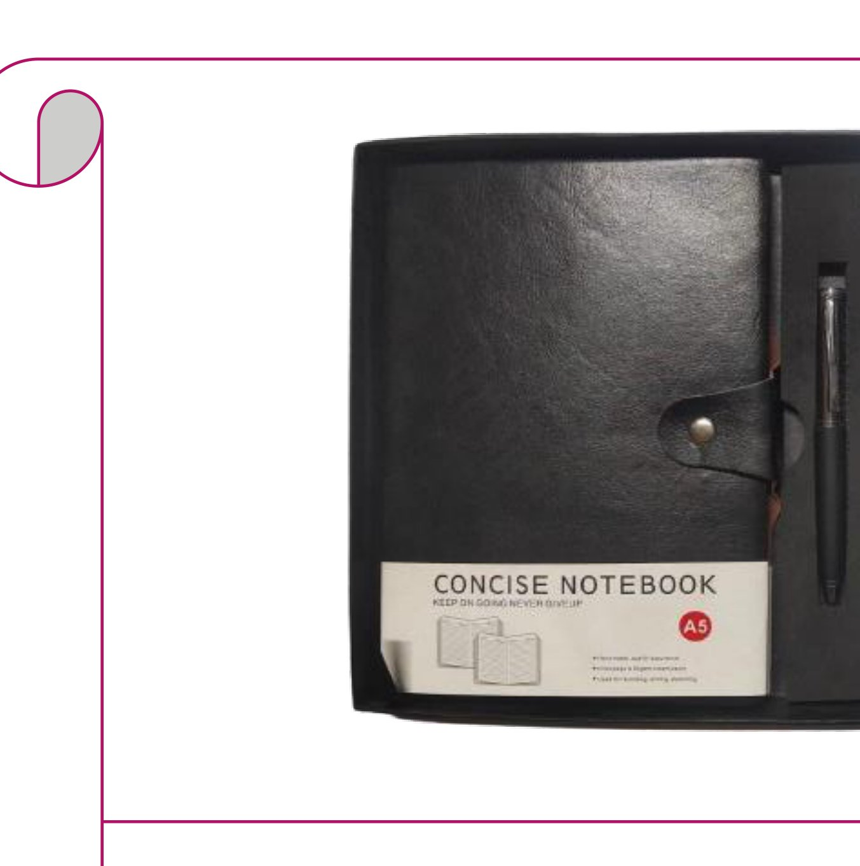  A5 Black Notebook + Pen  Black A5 concise notebook with pen loop strap and black pen  Rs. 177/- Base Rs. 150 + 18% GST
Item No. 25  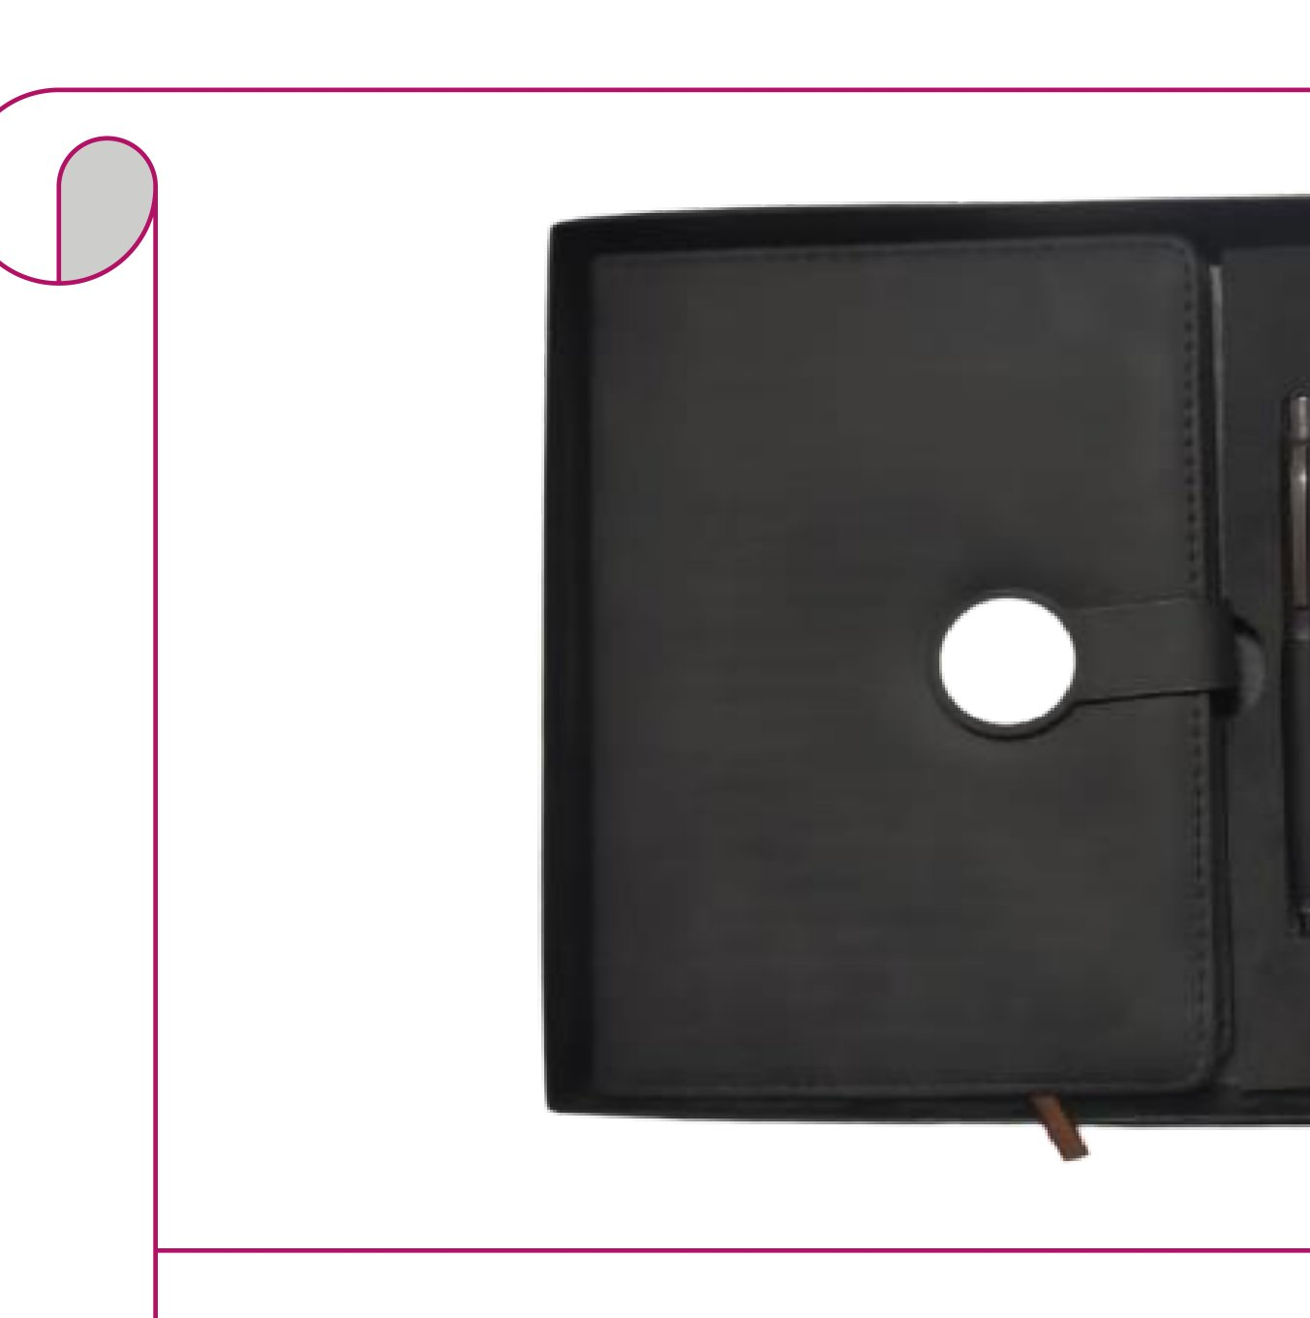  Magnet-Closure Diary + Pen  Dark charcoal magnet-closure diary with bookmark and black pen  Rs. 236/- Base Rs. 200 + 18% GST |  | Item No. 26  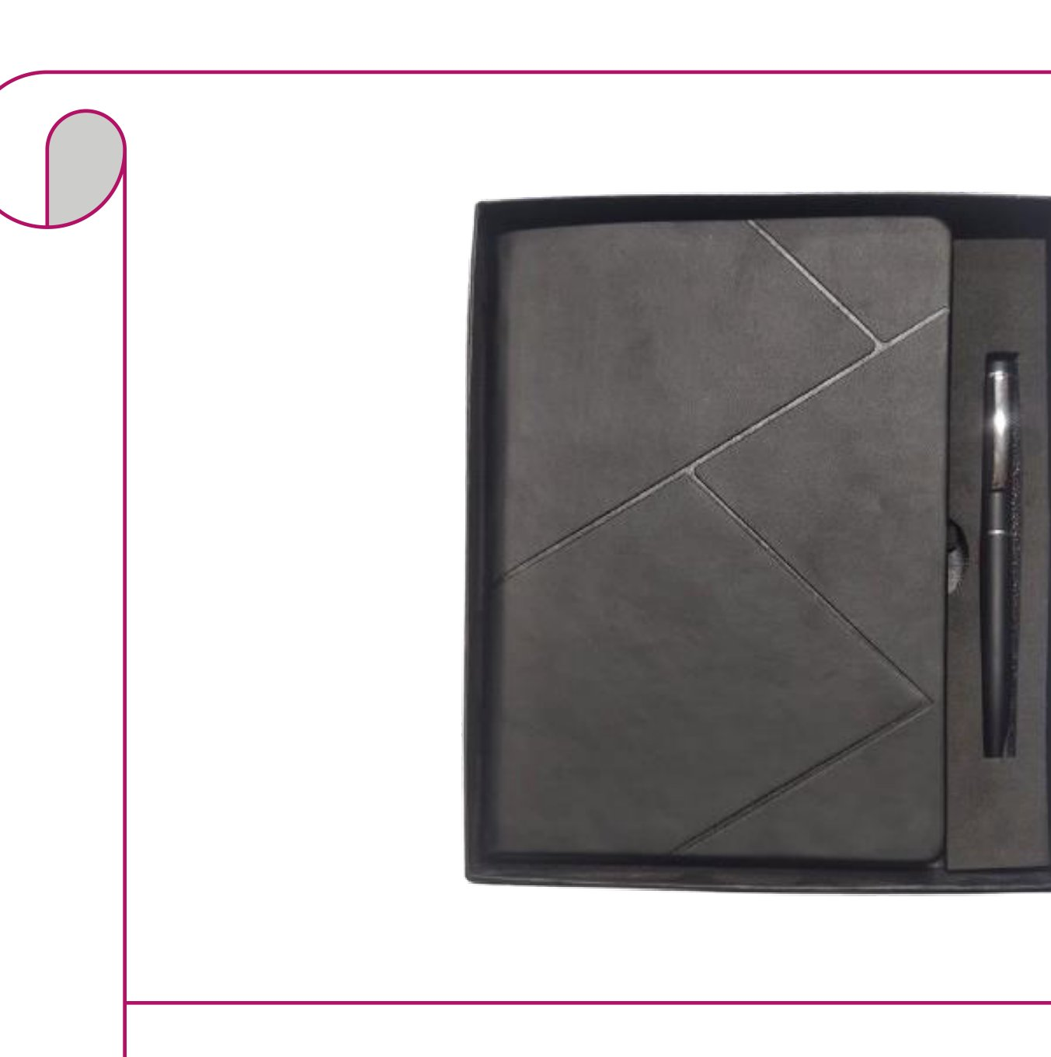  Dark Grey Triangle Diary + Pen  Dark grey suede diary with triangle-cut design and black pen  Rs. 207/- Base Rs. 175 + 18% GST
Item No. 27  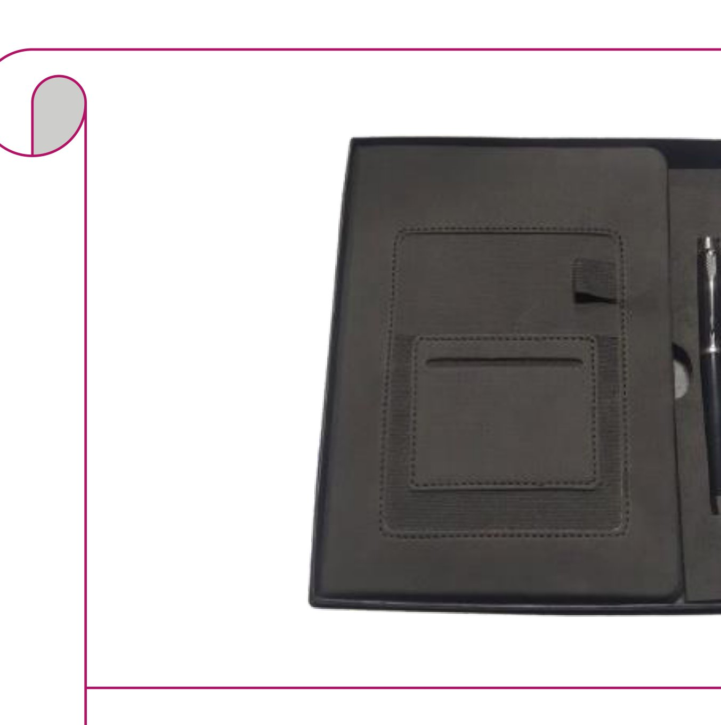  Grey Fabric Card-Pocket Diary + Pen  Dark grey fabric diary with card pockets, pen loop and chrome pen  Rs. 248/- Base Rs. 210 + 18% GST |  | Item No. 28  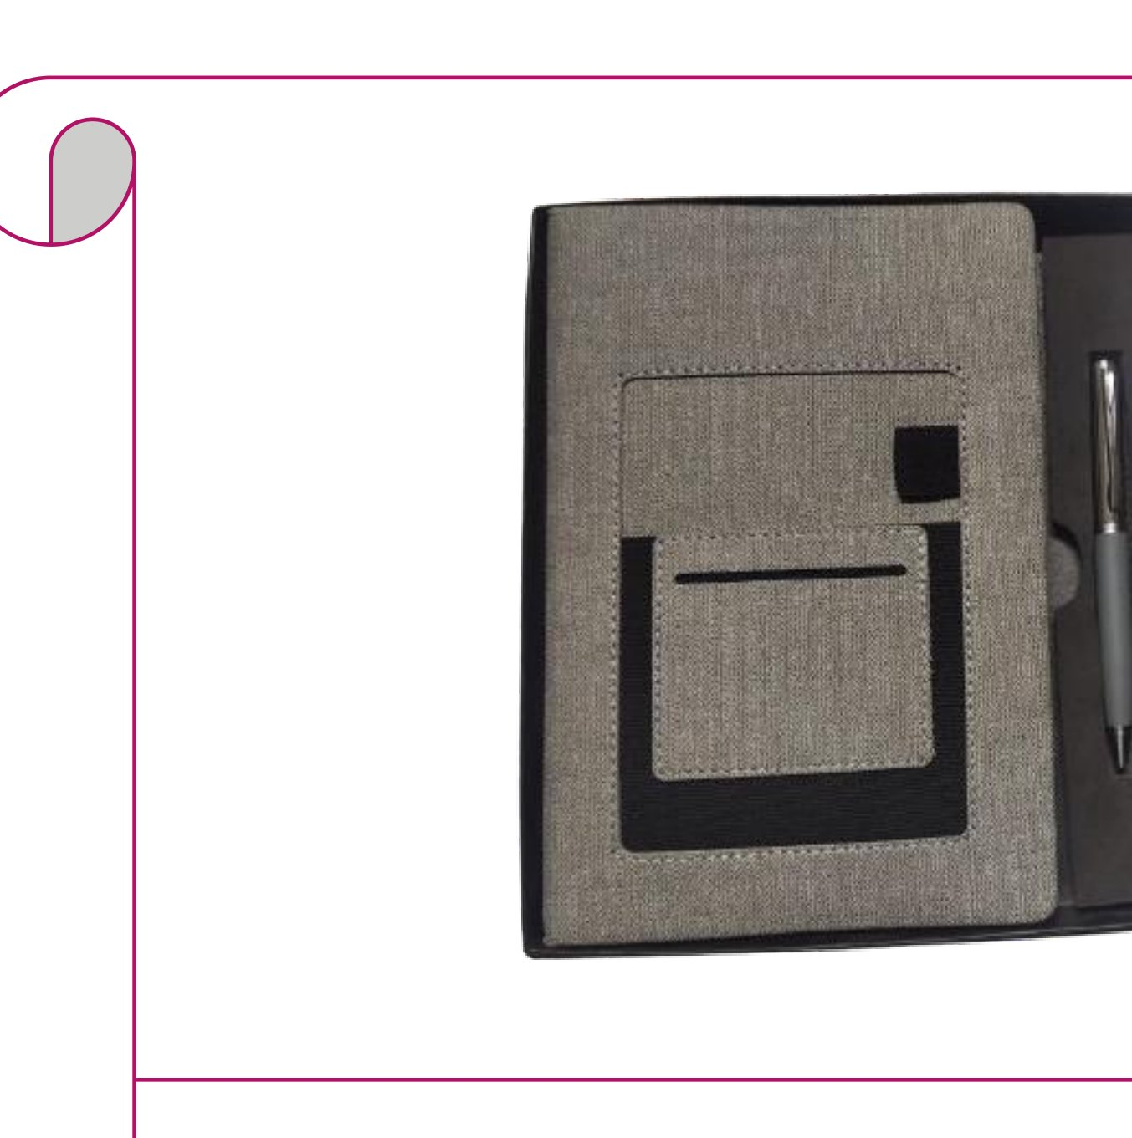  Grey Linen Card-Pocket Diary + Pen  Grey linen diary with card pockets, pen loop and silver pen  Rs. 248/- Base Rs. 210 + 18% GST
Item No. 29  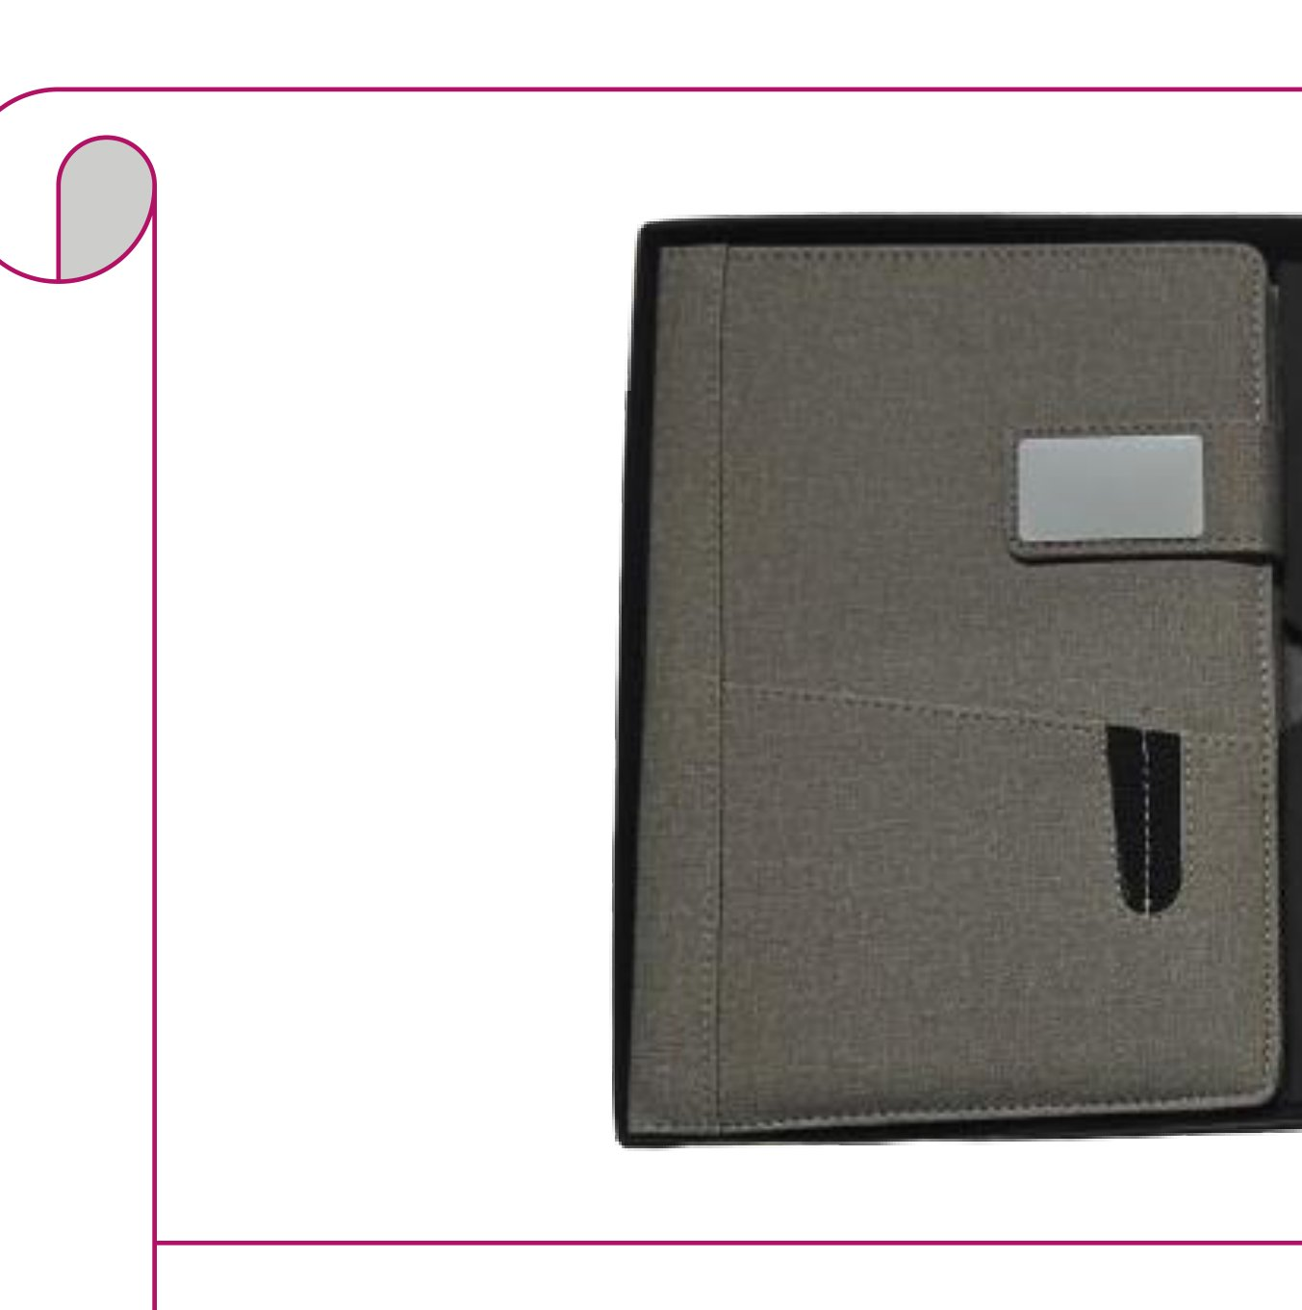  Grey Fabric Clasp Diary + Pen  Grey fabric diary with metal tab clasp and dark chrome pen  Rs. 295/- Base Rs. 250 + 18% GST |  | Item No. 30  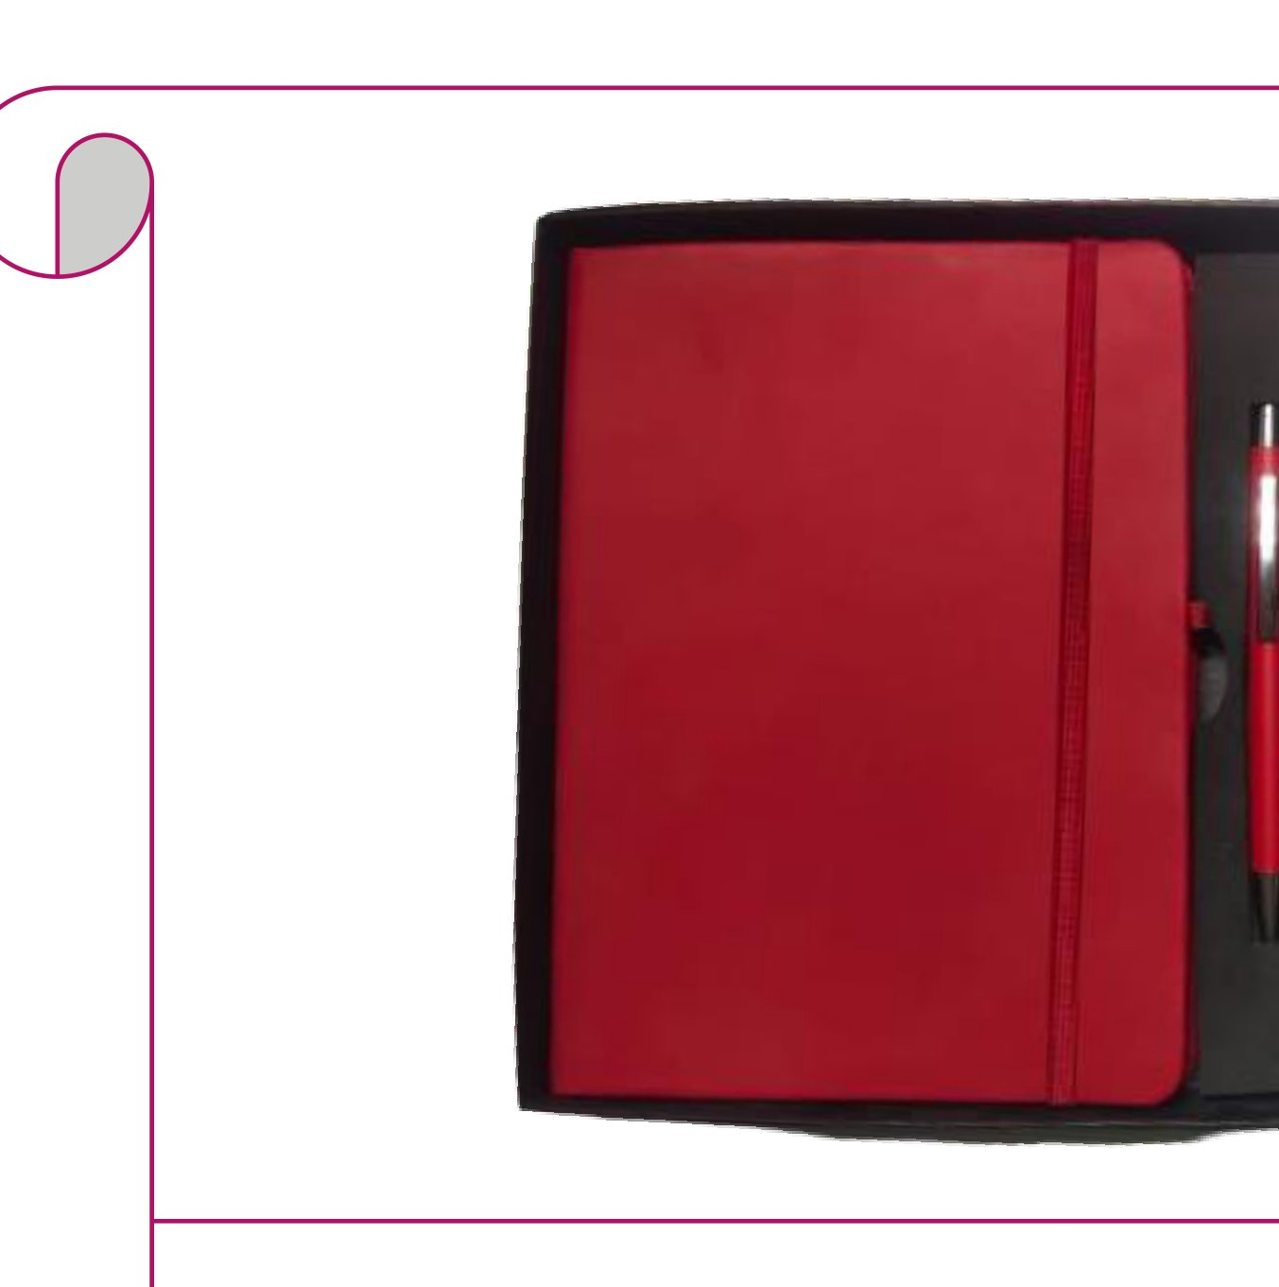  Red Elastic Diary + Red Pen  Red leatherette diary with elastic band and matching red pen  Rs. 177/- Base Rs. 150 + 18% GST
Item No. 31  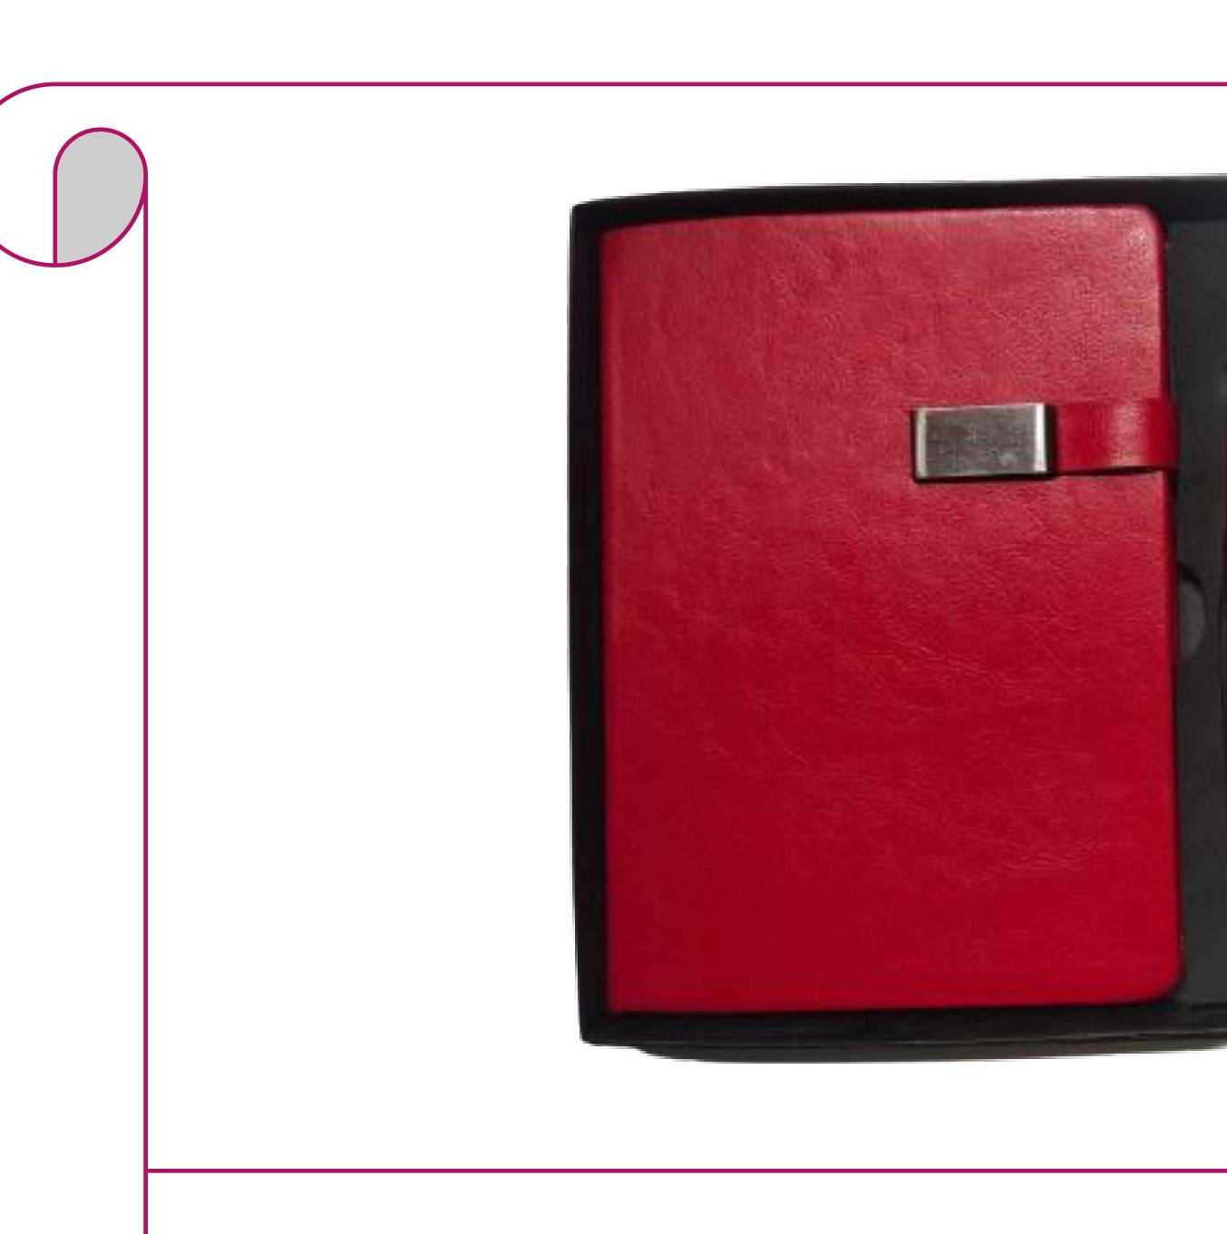  Red Leather Clasp Diary + Pen  Red leather diary with silver metal clasp and red pen  Rs. 212/- Base Rs. 180 + 18% GST |  | Item No. 32  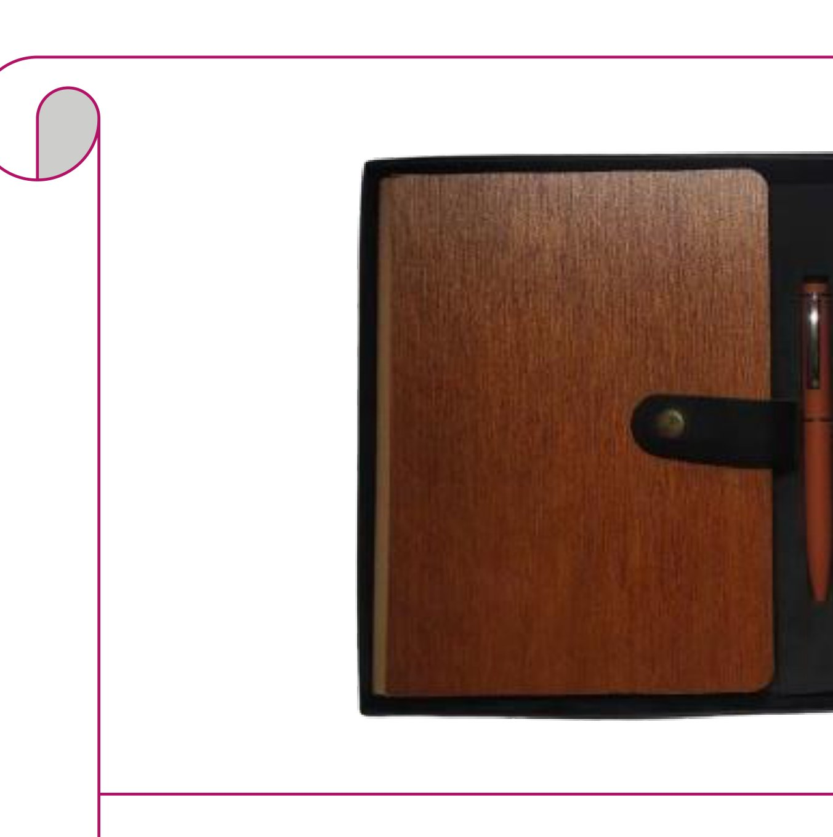  Wood-Grain Diary + Orange Pen  Wood-grain texture diary with pen loop and orange wooden-body pen  Rs. 236/- Base Rs. 200 + 18% GST
Item No. 33  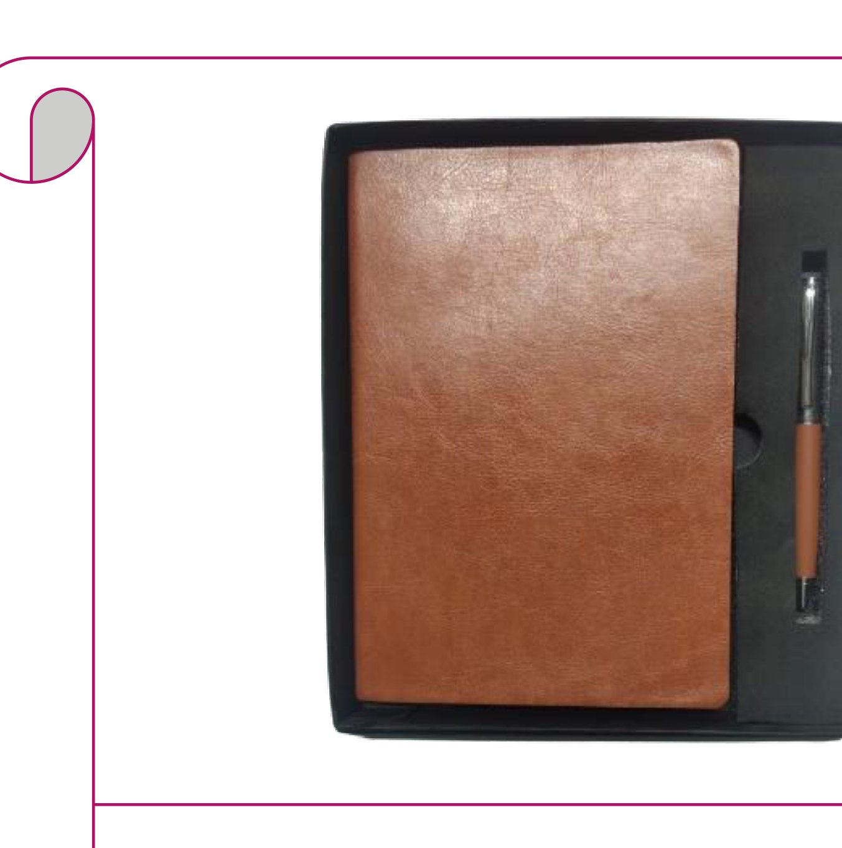  Soft Caramel Tan Diary + Pen  Caramel tan soft leatherette diary with a bronze-tipped pen  Rs. 165/- Base Rs. 140 + 18% GST |  | Item No. 34  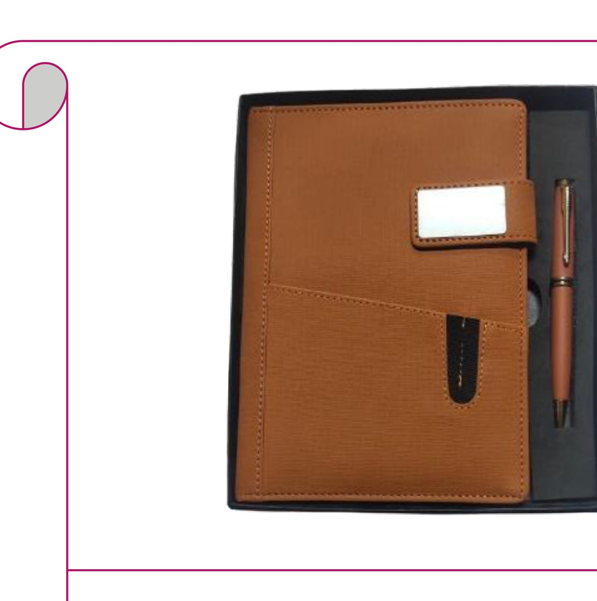  Tan Structured Diary + Wooden Pen  Tan structured diary with name-badge clasp and wooden-body pen  Rs. 295/- Base Rs. 250 + 18% GST
Item No. 35  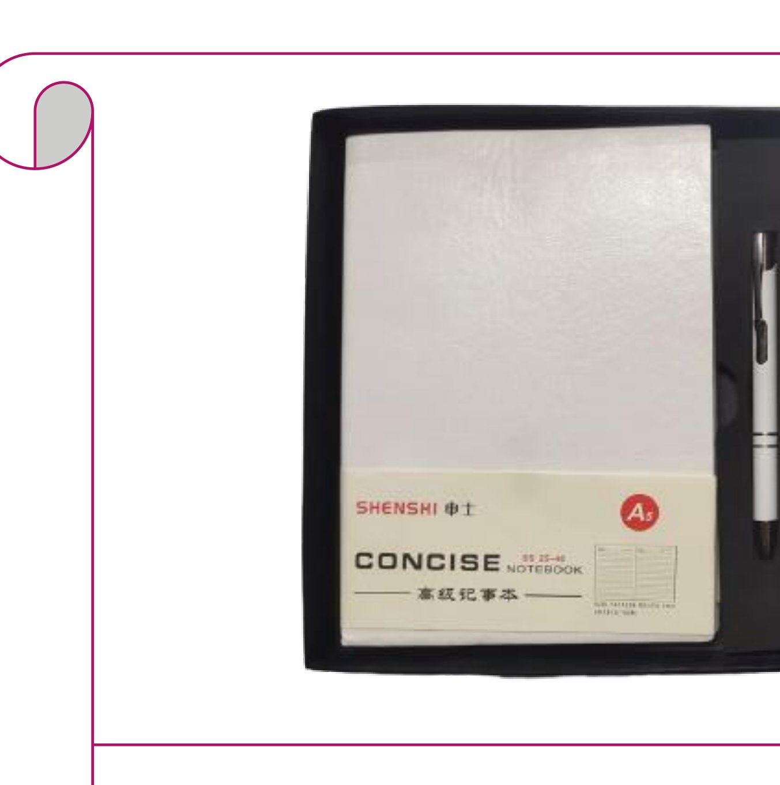  Soft White A5 Diary + Pen  White A5 soft concise notebook with white metal pen  Rs. 153/- Base Rs. 130 + 18% GST |  | Item No. 36  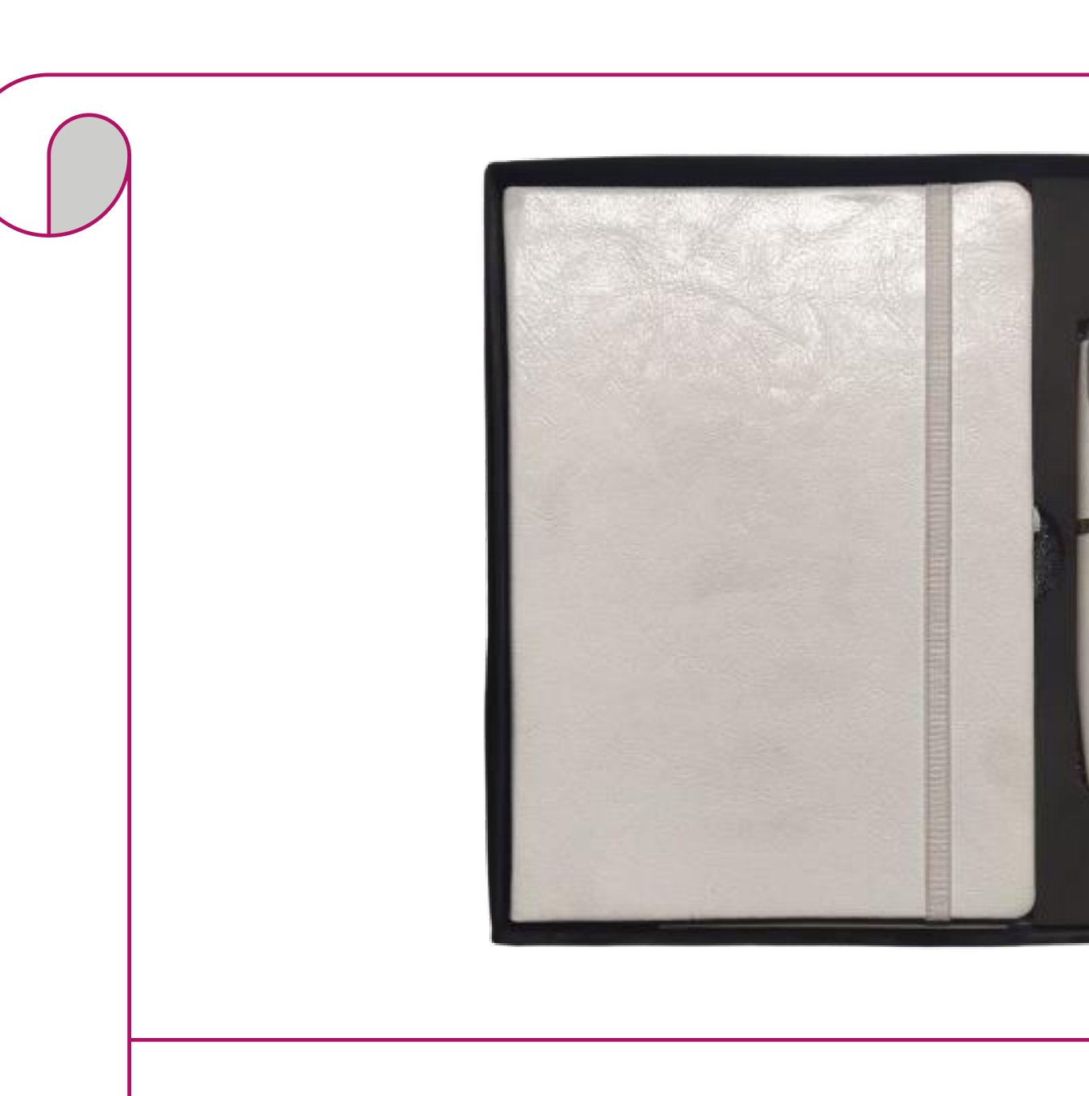  Pearl White Diary + Silver Pen  Pearl white leatherette diary with white elastic band and silver pen  Rs. 189/- Base Rs. 160 + 18% GST
Item No. 37  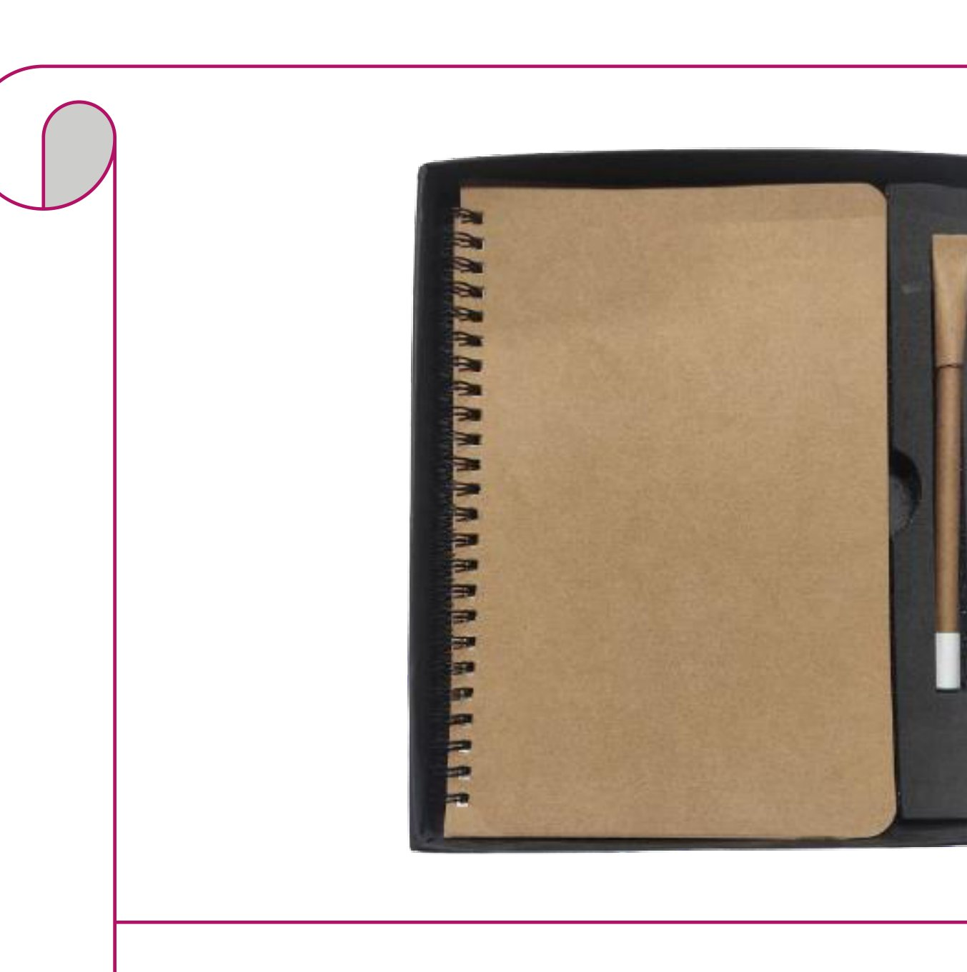  Kraft Spiral Notebook + Paper Pen  Eco kraft paper spiral notebook with matching kraft paper pen  Rs. 153/- Base Rs. 130 + 18% GST |  | Item No. 38  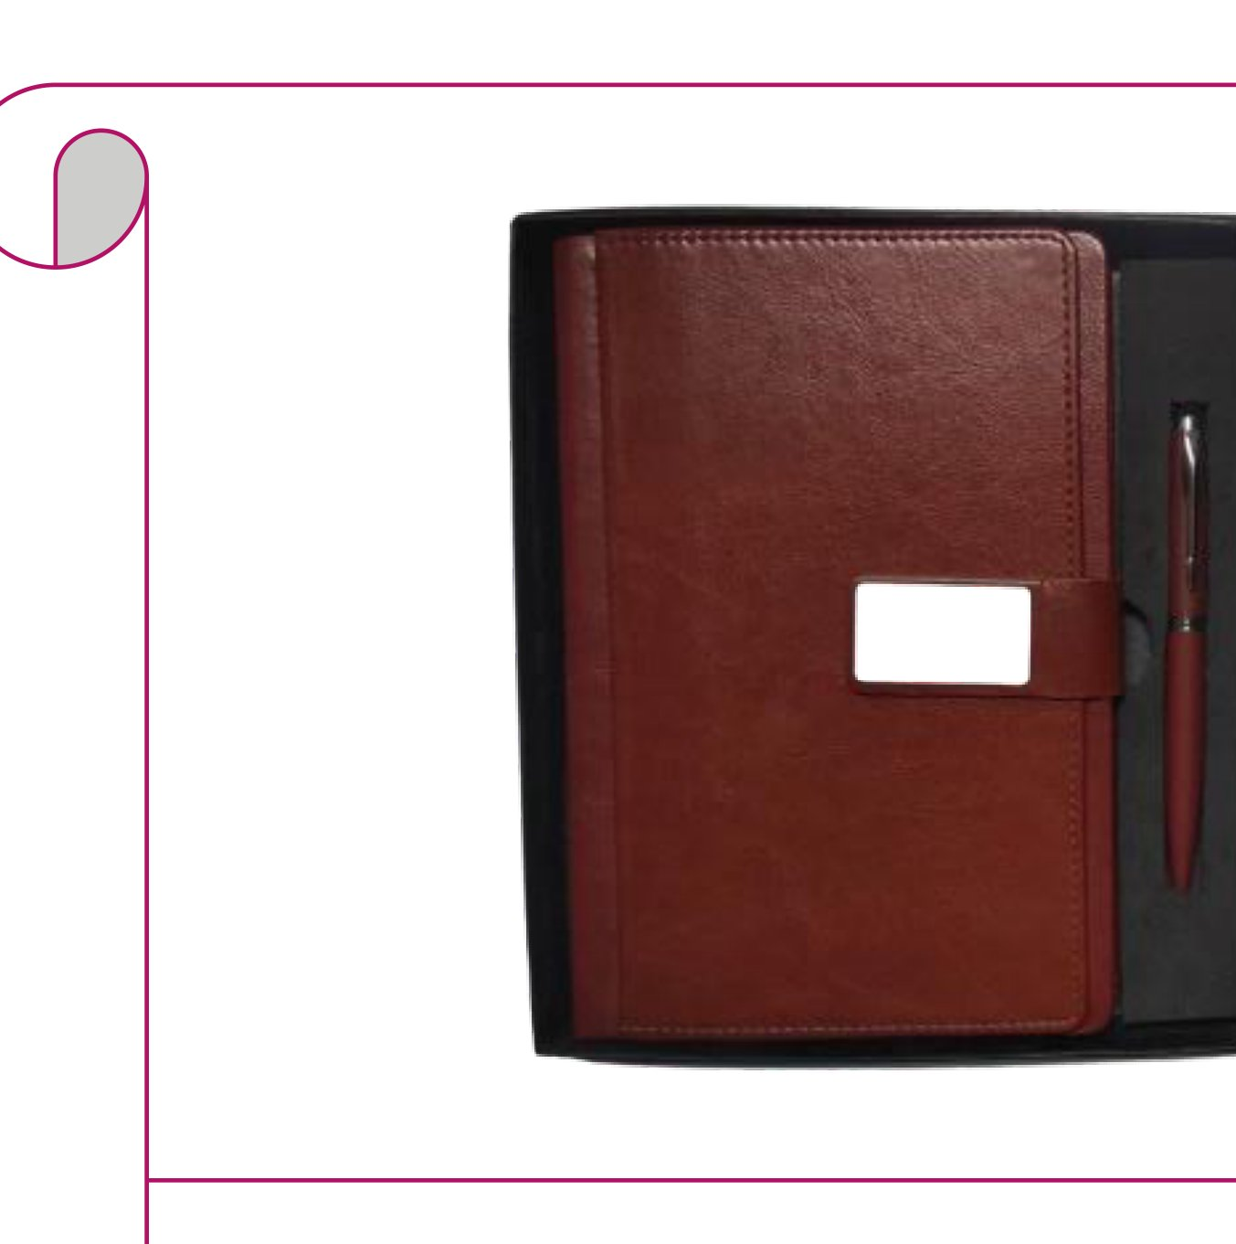  Double-Flap Diary with Planner + Pen  Cognac brown double-flap leather diary with planner insert and matching pen  Rs. 313/- Base Rs. 265 + 18% GST
Item No. 39  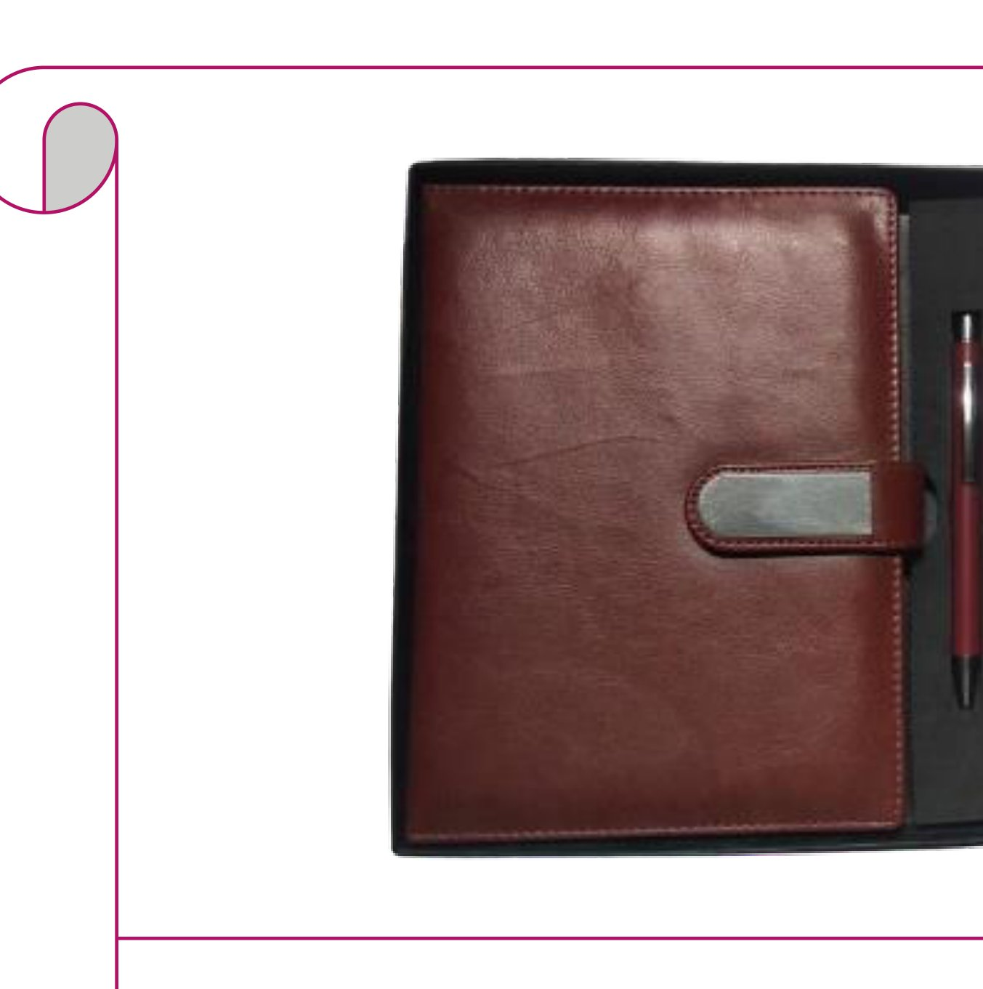  Brown Leather Clasp Diary + Pen  Brown leather diary with metal clasp and red pen  Rs. 283/- Base Rs. 240 + 18% GST |  | Item No. 40  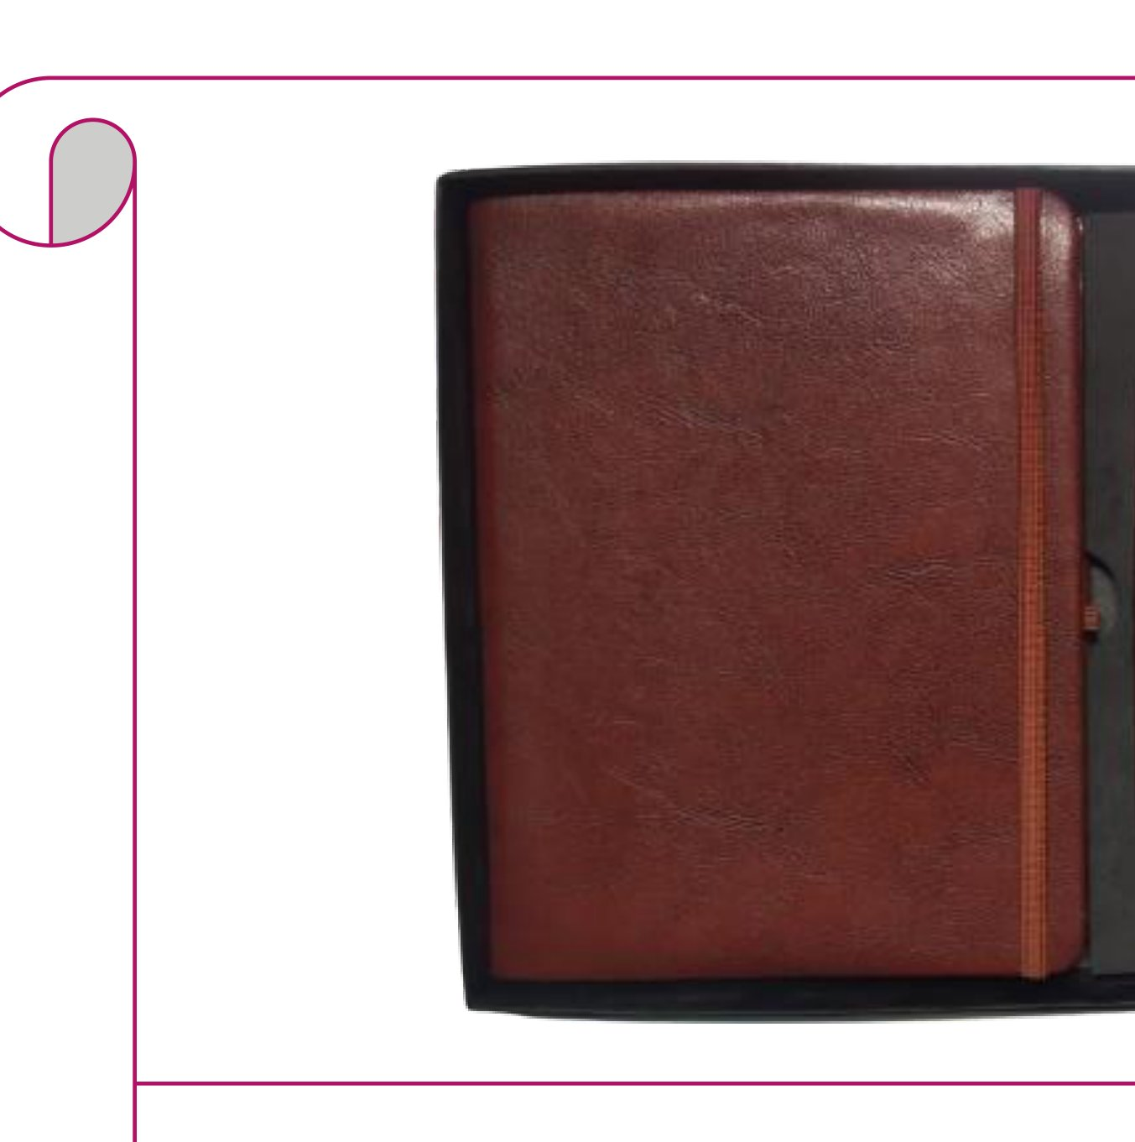  Brown Elastic Diary + Pen  Brown distressed leatherette diary with elastic band and brown pen  Rs. 177/- Base Rs. 150 + 18% GST
Item No. 41  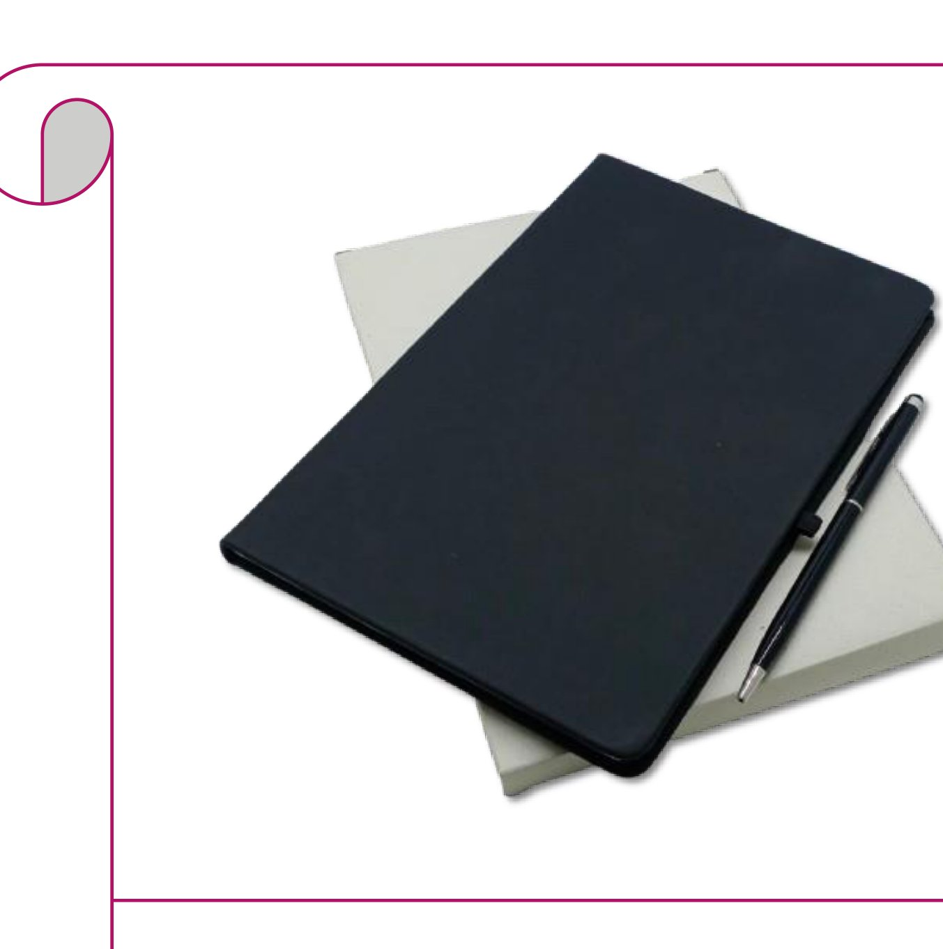  A5 Slim Black Diary + Cross Pen  Slim black A5 leather diary with elastic loop and metal cross-tip pen  Rs. 142/- Base Rs. 120 + 18% GST |  | Item No. 42  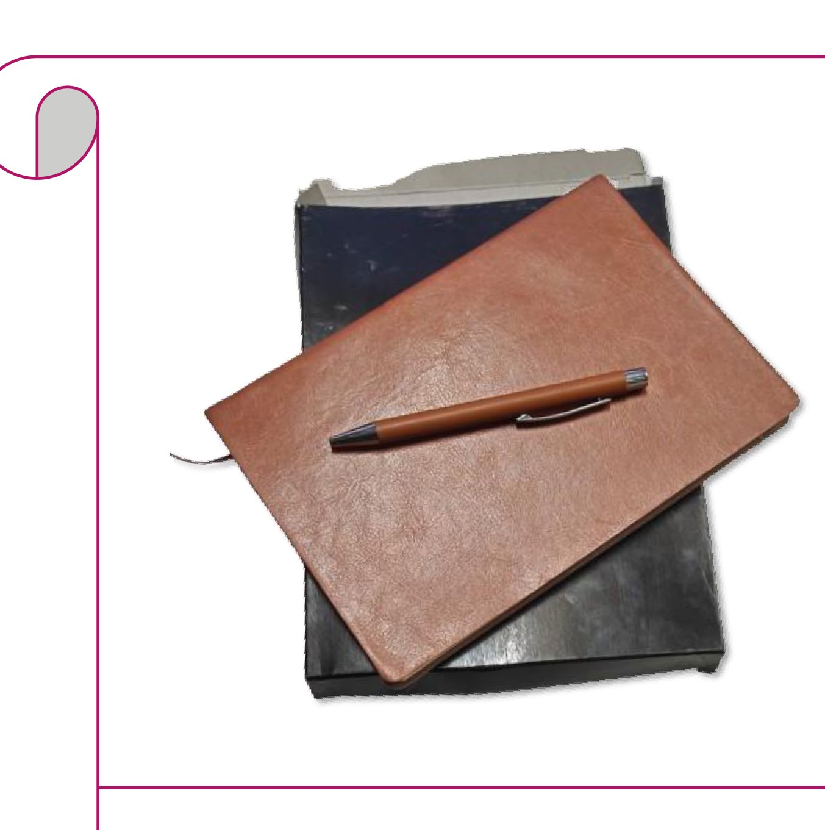  A5 Soft Brown Diary + Pen  Brown A5 soft leatherette cover diary with matching ballpoint pen  Rs. 118/- Base Rs. 100 + 18% GST
Item No. 43
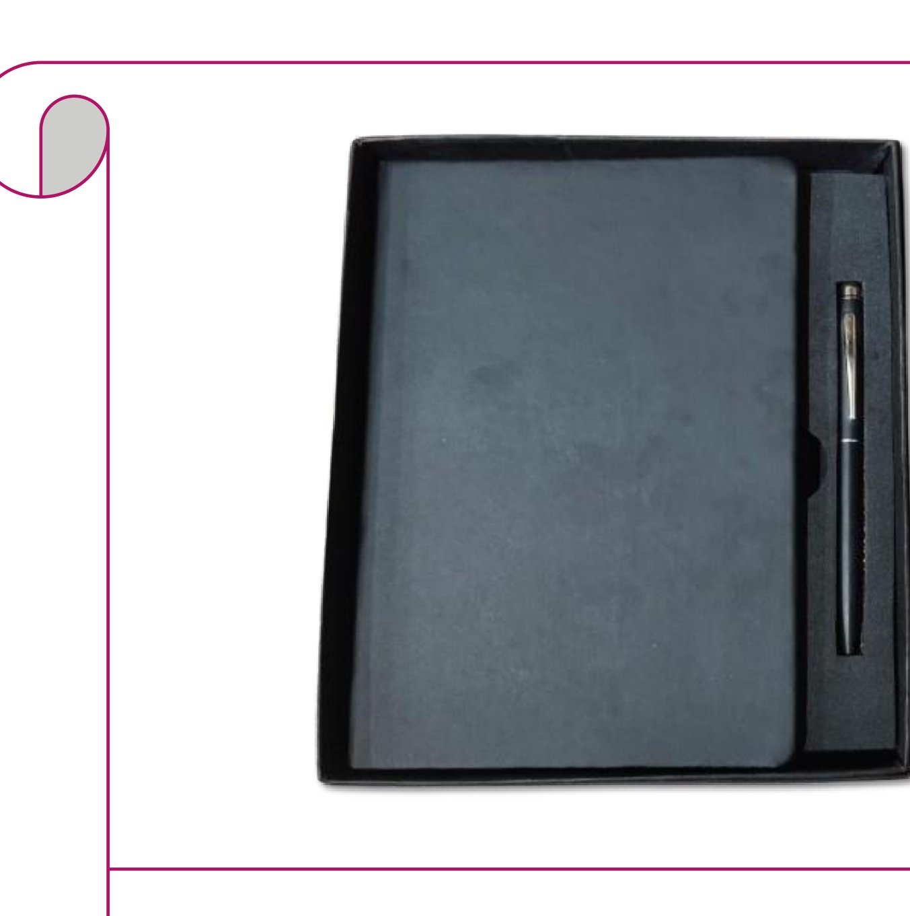
Diary + Cross Touch Pen
Dark slate-blue leatherette diary with stylus touch cross pen
Rs. 207/- Base Rs. 175 + 18% GST

Thank you
for considering Robust Gifting

All items available for custom branding.
Minimum order quantities and lead times on request.
Prices are exclusive of 18% GST. Valid 2026.

